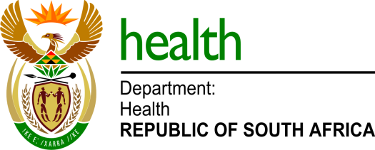
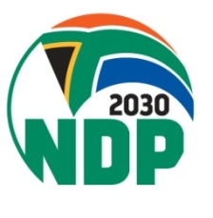

MEDIA ADVISORY

To: Editors & Health Journalists
Issued by: Department of Health
Date: Sunday, 14 May 2023

Health Deputy Minister Dhlomo to lead Ex-Miners Compensation Fund and Youth outreach programmes in Mandeni, KwaZulu-Natal

The Deputy Minister of Health, Dr Sibongiseni Dhlomo will tomorrow 15 May, lead a dialogue with young people of Mandeni and neighbouring communities to promote access to healthcare services, especially sexual reproductive health.

The Department of Health has established Youth Zones in primary health facilities as part to create conducive environment for adolescent girls and young women as part of efforts to address the scourge of teenage and unplanned pregnancies.

The Zones are designed to meet the practical and psychosocial needs of young people by including operating times that are dedicated and suitable to the youth.

The Deputy Minister Dhlomo will be joined by the Deputy Ministers of the Department of Employment and Labour, Ms Boitumelo Moloi and Mineral Resources and Energy, Dr Nobuhle Nkabane as they embark on the ex-miners compensation fund outreach programme.

For RVSP and more information, please contact Howard Kgoa at 079 876 9247 or Howard.kgoa@health.gov.za

Details of the event are as follows:

Date: Monday, 15 May 2023
Time: 10h00
Venue: Ngcendomhlophe Sports Field, Mandeni Local Municipality in Ilembe District, ward 15

For media enquiries, please contact:

Mr Foster Mohale
Health Department Spokesperson
072 432 3792
Foster.mohale@health.gov.za

