Sexually transmitted infections
12.1 Vaginal discharge syndrome (VDS)
12.1.1 Sexually non-active women
12.1.2 Sexually active women
12.2 Lower abdominal pain (LAP)
12.3 Male urethritis syndrome (MUS)
12.4 Scrotal swelling (SSW)
12.5 Genital ulcer syndrome (GUS)
12.6 Bubo
12.7 Balanitis/balanoposthitis (BAL)
12.8 Syphilis serology and treatment
12.9 Treatment of more than one STI syndrome
12.10 Treatment of partners
12.11 Genital molluscum contagiosum (MC)
12.12 Genital warts (GW): Condylomata Accuminata
12.13 Pubic lice (PL)

The syndromic approach to Sexually Transmitted Infections (STIs) diagnosis and management is to treat the signs or symptoms (syndrome) of a group of diseases rather than treating a specific disease. This allows for the treatment of one or more conditions that often occur at the same time and has been accepted as the management of choice.

Causative organisms and medicine management for STI syndromes:
ORGANISM | SYNDROME/S | MEDICINE MANAGEMENT
Neisseria gonorrhoeae | VDS, MUS, LAP | ceftriaxone + azithromycin
  LoE:III
Chlamydia trachomatis | VDS, MUS, LAP, GUS, Bubo | azithromycin
Trichomonas vaginalis | VDS, LAP | metronidazole
Bacterial vaginosis (overgrowth of Gardnerella vaginalis, lactobacillus, anaerobes etc.) | VDS | metronidazole
Candida albicans | VDS | clotrimazole
Treponema pallidum | GUS | doxycycline/ benzathine benzylpenicillin
Herpes simplex | GUS | aciclovir
Haemophilus ducreyi | GUS, Bubo | azithromycin
It is important to take a good sexual history and undertake a thorough ano-genital examination in order to perform a proper clinical assessment. The history should include questions concerning symptoms, recent sexual history, sexual orientation, type of sexual activity (oral, vaginal, anal sex), the possibility of pregnancy (females), use of contraceptives including condoms, recent antibiotic history, antibiotic allergy, recent overseas travel and domestic violence. Refer to a social worker, as required.
Note: Standard referral letter for treatment failure must include the following:
reason for referral: presumptive diagnosis (e.g. persistent cervicitis with suspected resistant gonorrhoea)
clinical findings including speculum examination for vaginal discharge
treatment history (including all medicines with dose and duration)
details of notification and treatment history of partner(s)
Suspected STI in children should be referred to hospital for further investigation and management.

GENERAL MEASURES
Counselling and education, including HIV testing.
Condom promotion, provision and demonstration to reduce the risk of STIs.
Compliance/ adherence with treatment.
Contact treatment/ partner management.
Circumcision promotion (counselling to continue condom use).
Cervical cancer screening.
Promote HIV counselling and testing.
For negative test results repeat test after 6 weeks, because of the window period.

Benzathine benzylpenicillin
Benzathine benzylpenicillin remains the recommended treatment for syphilis. Azithromycin is not recommended for the treatment of syphilis in pregnancy as azithromycin does not effectively treat syphilis in the fetus, and resistance develops rapidly to macrolides. Therefore, benzathine benzylpenicillin should be reserved for use in pregnant women and children during times of a confirmed stock shortage.

Vaginal discharge syndrome (VDS)
B37.3/N76.0/N89.8

Sexually non-active women
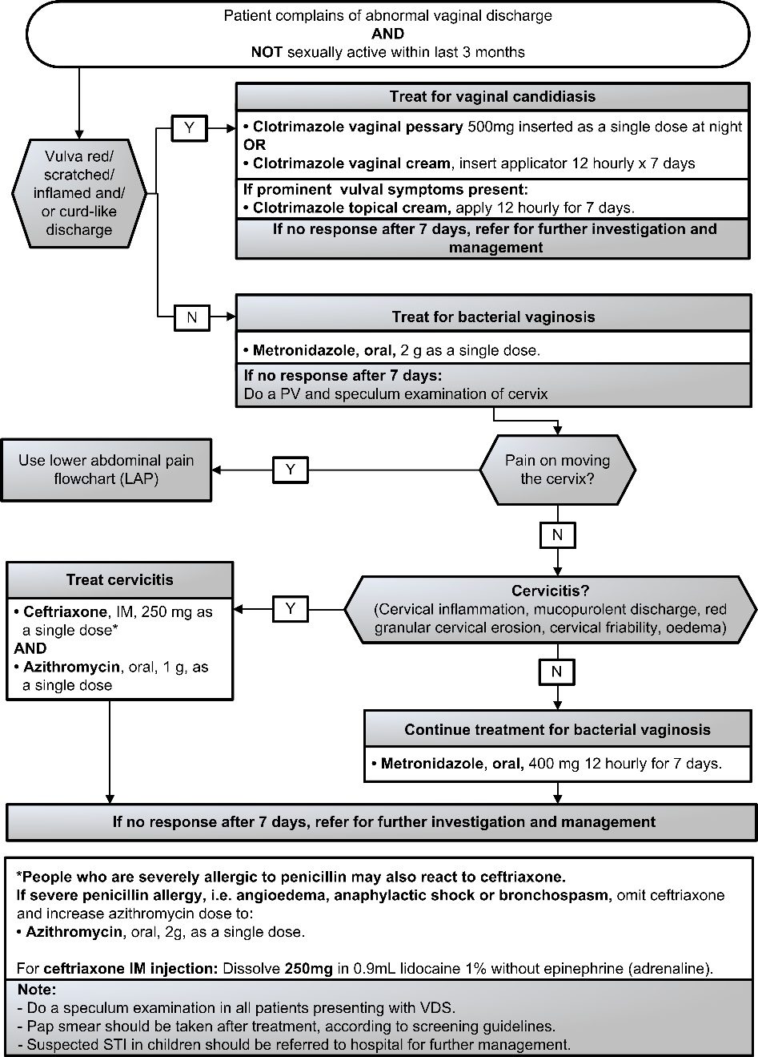
LoE:III

Sexually active women
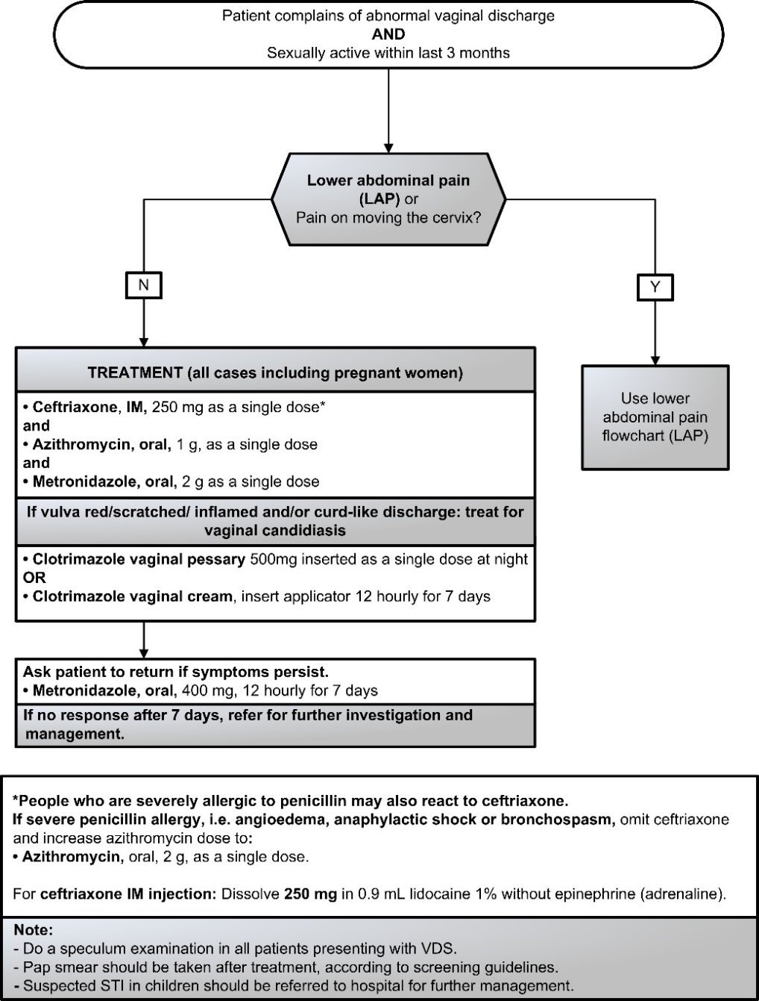
LoE:III

Lower abdominal pain (LAP)
N73.9
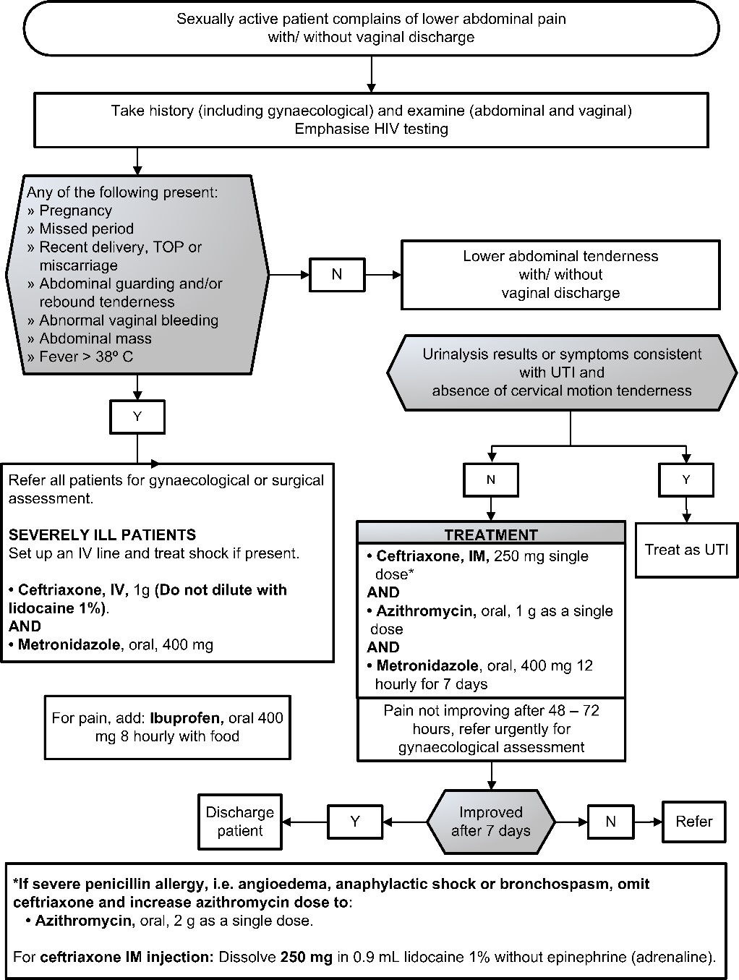

Male urethritis syndrome (MUS)
A64 + N34.1
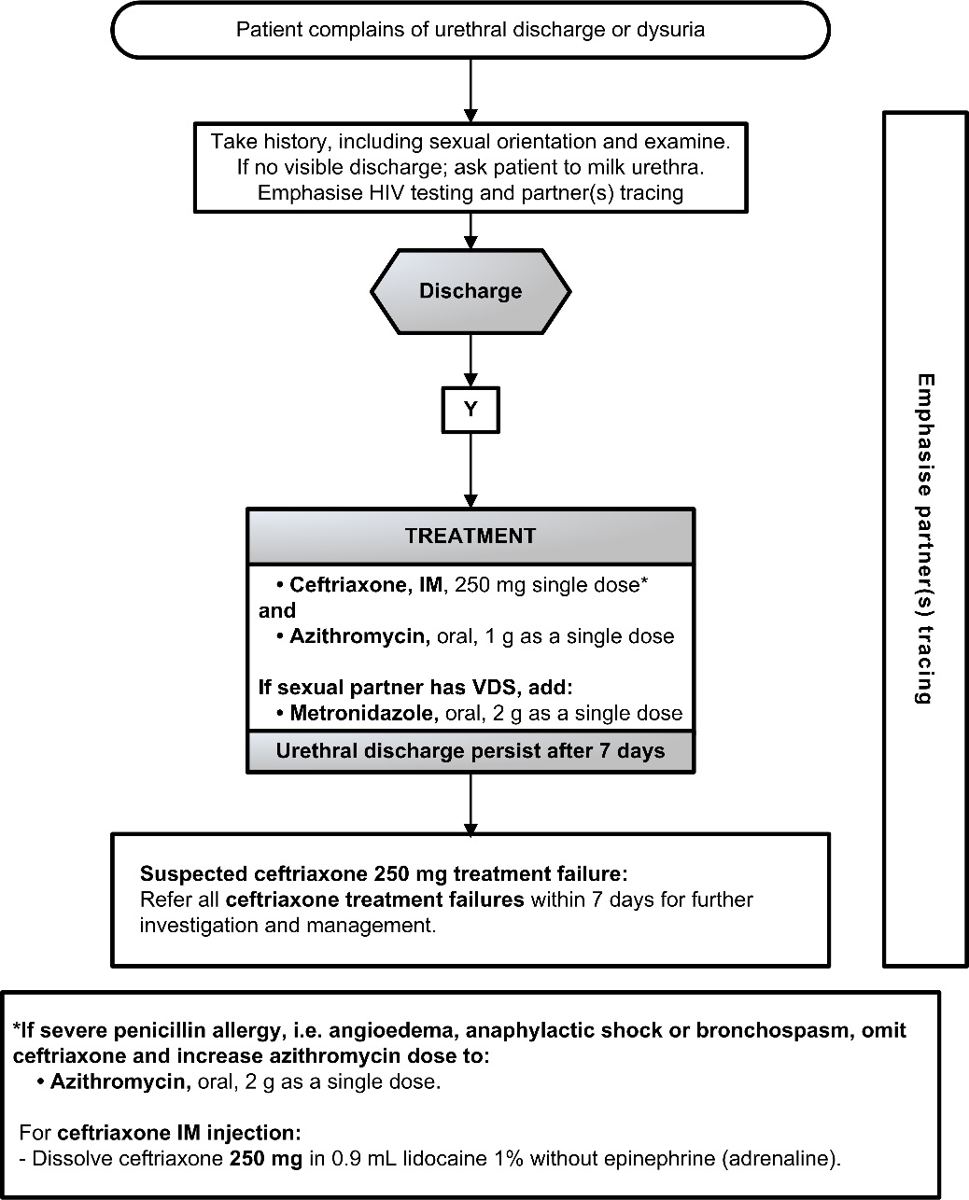

Scrotal swelling (SSW)
N45.1
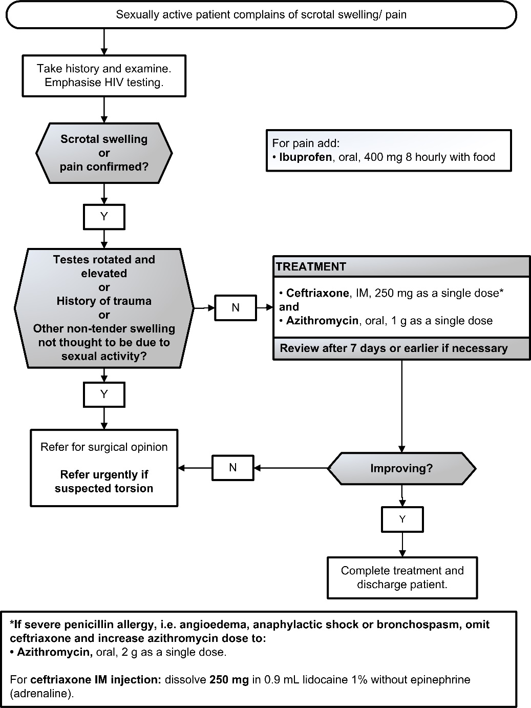

Genital ulcer syndrome (GUS)
LoE:III
A60.9/A51.0
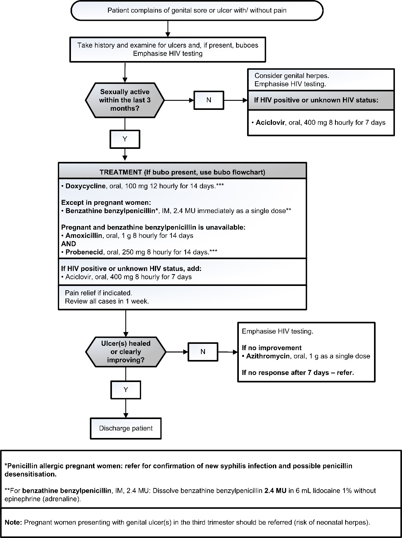

LoE:II

Bubo
A58
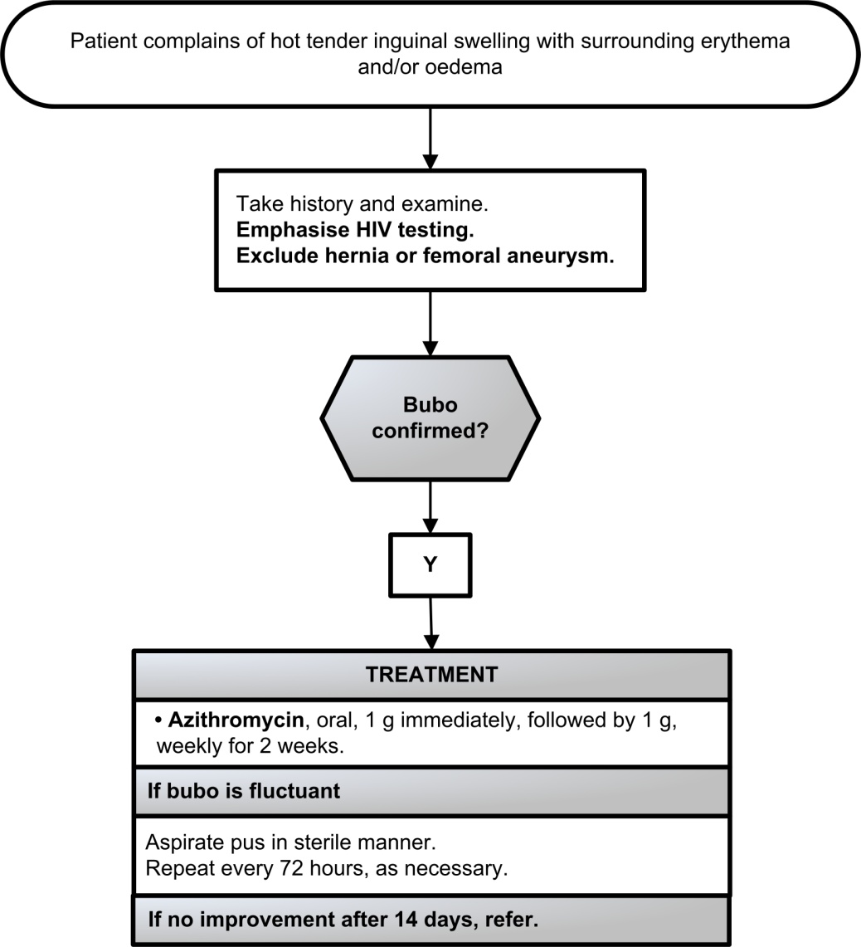

LoE:III

Balanitis/balanoposthitis (BAL)
N48.1
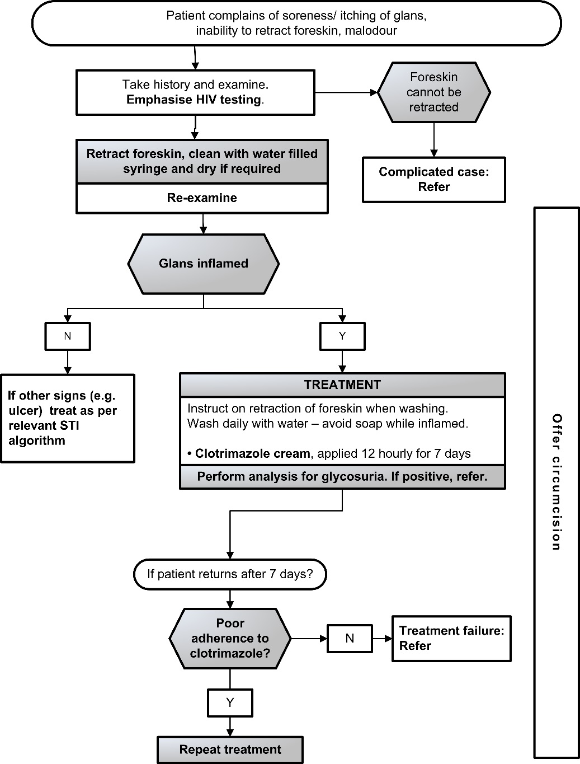

Syphilis serology and treatment

A53.9

Syphilis serology
The Rapid Plasmin Reagin (RPR) measures disease activity, but is not specific for syphilis. False RPR-positive reactions may occur, notably in patients with connective tissue disorders (false positive reactions are usually low titre <1:8). For this reason, positive RPR results should be confirmed due to syphilis by further testing of the serum with a specific treponemal test, e.g.:
Treponema pallidum haemagglutination (TPHA) assay.
Treponema pallidum particle agglutination (TPPA) assay.
Fluorescent Treponemal Antibody (FTA) assay.
Treponema pallidum ELISA.
Rapid treponemal antibody test (TPAb)
Screening can also be done the other way around starting with a specific treponemal test followed by a RPR in patients who have a positive specific treponemal test. This is sometimes referred to as the “reverse algorithm”.
- Once positive, specific treponemal tests generally remain positive for life and therefore the presence of specific treponemal antibodies cannot differentiate between current and past infections
- A person with previously successfully treated syphilis will retain lifelong positive specific treponemal test results.
The RPR can be used:
To determine if the patient’s syphilis disease is active or not,
To measure a successful response to therapy (at least a fourfold reduction in titre, e.g. 1:256 improving to 1:64), or
To determine a new re-infection.
Some patients, even with successful treatment for syphilis, may retain life-long positive RPR results at low titres (≤1:8), which do not change by more than one dilution difference (up or down) over time (so-called serofast patients).
Note:
Up to 30% of early primary syphilis cases, i.e. those with genital ulcers may have a negative RPR.
LoE:II
The RPR is always positive in the secondary syphilis stage and remains high during the first two (infectious) years of syphilis.

For syphilis treatment in pregnancy, see Section 6.4.4: Syphilis in pregnancy.

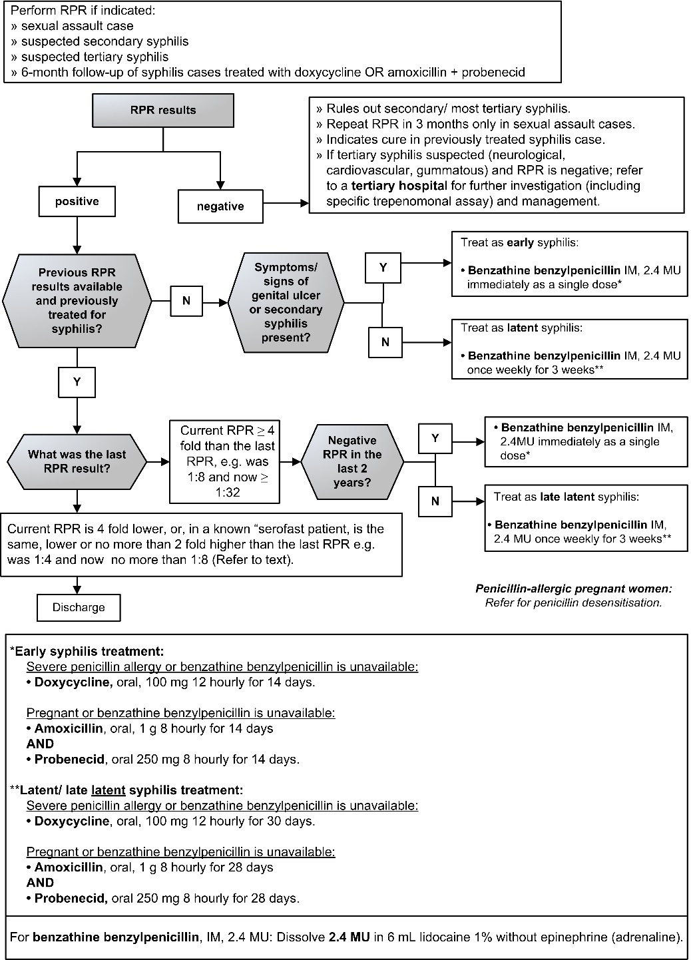

MEDICINE TREATMENT

Early syphilis treatment
Check if treated at initial visit.
- Benzathine benzylpenicillin, IM, 2.4 MU immediately as a single dose .
- Dissolve benzathine benzylpenicillin, IM, 2.4 MU in 6 mL lidocaine 1% without adrenaline (epinephrine).

In penicillin-allergic patients or if benzathine benzylpenicillin is unavailable:
Z88.0
LoE:III
- Doxycycline, oral, 100 mg 12 hourly for 14 days.

If pregnant and benzathine benzylpenicillin is unavailable:
- Amoxicillin, oral 1 g 8 hourly for 14 days (Doctor initiated).
AND
LoE:III
- Probenecid, oral 250 mg, 8 hourly for 14 days (Doctor initiated).
If penicillin-allergic and pregnant: Refer for penicillin desensitisation.

Late/ late latent syphilis treatment
Check if treatment was commenced at initial visit.
- Benzathine benzylpenicillin, IM, 2.4 MU once weekly for 3 weeks.
- Dissolve benzathine benzylpenicillin, IM, 2.4 MU in 6 mL lidocaine 1% without adrenaline (epinephrine).

In penicillin-allergic patients or if benzathine benzylpenicillin is unavailable:
Z88.0
LoE:III
- Doxycycline, oral, 100 mg 12 hourly for 30 days.

If pregnant and benzathine benzylpenicillin is unavailable:
- Amoxicillin, oral 1 g 8 hourly for 28 days (Doctor initiated).
AND
LoE:III
- Probenecid, oral 250 mg, 8 hourly for 28 days (Doctor initiated).
If penicillin-allergic and pregnant: Refer for penicillin desensitisation.

REFERRAL
Tertiary syphilis: neurosyphilis, cardiovascular syphilis; gummatous syphilis.
Clinical congenital syphilis.

Treatment of more than one STI syndrome

STI SYNDROMES | TREATMENT (NEW EPISODE)
MUS + SSW | Treat according to SSW flow chart.
MUS + BAL | Treat according to MUS flow chart.  AND  - Clotrimazole cream, 12 hourly for 7 days.
MUS + GUS | - Ceftriaxone, IM, 250 mg immediately as a single dose.  AND  - Azithromycin, oral, 1 g as a single dose.  AND  - Aciclovir, oral, 400 mg 8 hourly for 7 days*.
VDS + LAP | Treat according to LAP flow chart.  AND  Treat for candidiasis, if required (see VDS flow chart).
VDS + GUS | - Ceftriaxone, IM, 250 mg immediately as a single dose.  AND  - Metronidazole, oral, 2 g immediately as a single dose.  AND  - Azithromycin, oral, 1 g as a single dose.  AND  - Aciclovir, oral, 400 mg 8 hourly for 7 days*.  AND  Treat for candidiasis, if required (see VDS flow chart).
LAP+ GUS | - Ceftriaxone, IM, 250 mg immediately as a single dose.  AND  - Metronidazole, oral, 400 mg 12 hourly for 7days.  AND  - Aciclovir, oral, 400 mg 8 hourly for 7 days*.  AND  - Azithromycin, oral, 1 g as a single dose.
SSW+ GUS | - Ceftriaxone, IM, 250 mg immediately as a single dose.  AND  - Aciclovir, oral, 400 mg 8 hourly for 7 days*.  AND  - Azithromycin, oral, 1 g as a single dose.
*Treat with aciclovir only if HIV status is positive or unknown.
**Penicillin allergic men and non-pregnant women avoid ceftriaxone and refer to relevant algorithms.
Penicillin allergic pregnant/breastfeeding women, refer for penicillin desensitisation.

Treatment of partners

Syndrome | Asymptomatic partner | Symptomatic partner
VDS | - Ceftriaxone, IM, 250 mg immediately as a single dose.  AND  - Metronidazole, oral, 2 g immediately as a single dose.  AND  - Azithromycin, oral, 1 g as a single dose. | - Ceftriaxone, IM, 250 mg immediately as a single dose.  AND  - Metronidazole, oral, 2 g immediately as a single dose.  AND  - Azithromycin, oral, 1 g as a single dose.  PLUS treatment for syndrome present if not included in the above.
LAP | - Ceftriaxone, IM, 250 mg immediately as a single dose.  AND  - Metronidazole, oral, 2 g immediately as a single dose.  AND  - Azithromycin, oral, 1 g as a single dose. | - Ceftriaxone, IM, 250 mg immediately as a single dose.  AND  - Metronidazole, oral, 2 g immediately as a single dose.  AND  - Azithromycin, oral, 1 g as a single dose.  PLUS treatment for syndrome present if not included in the above.
MUS | - Ceftriaxone, IM, 250 mg immediately as a single dose.  AND  - Azithromycin, oral, 1 g as a single dose. | - Ceftriaxone, IM, 250 mg immediately as a single dose.  AND  - Azithromycin, oral, 1 g as a single dose.  PLUS treatment for syndrome present if not included in the above (see VDS flow chart).
Scrotal swelling | - Ceftriaxone, IM, 250 mg immediately as a single dose.  AND  - Azithromycin, oral, 1 g as a single dose. | - Ceftriaxone, IM, 250 mg immediately as a single dose.  AND  - Azithromycin, oral, 1 g as a single dose.  PLUS treatment for syndrome present if not included in the above.
GUS | - Doxycycline, oral, 100 mg 12 hourly for 14 days.  Except pregnant women:  - Benzathine benzylpenicillin, IM, 2.4 MU immediately as a single dose.  - Dissolve benzathine benzylpenicillin, IM, 2.4 MU in 6 mL lidocaine 1% without epinephrine (adrenaline).  (If pregnant and benzathine benzylpenicillin is unavailable, see syphilis flow chart). | - Doxycycline, oral, 100 mg 12 hourly for 14 days.  Except pregnant women:  - Benzathine benzylpenicillin, IM, 2.4 MU immediately as a single dose.  - Dissolve benzathine benzylpenicillin, IM, 2.4 MU in 6 mL lidocaine 1% without epinephrine (adrenaline).  PLUS treatment for syndrome present if not included in the above.  (If pregnant and benzathine benzylpenicillin is unavailable, see syphilis flow chart).
Bubo | - Azithromycin, oral, 1 g as a single dose. | - Azithromycin, oral, 1 g as a single dose.  PLUS treatment for syndrome present if not included in the above.
LoE:III

Genital molluscum contagiosum (MC)
B08.1

DESCRIPTION
This is a viral infection which can be transmitted sexually and non-sexually. It is usually self-limiting but can be progressive in an advanced stage of immunodeficiency.
Clinical signs include papules at the genitals or other parts of the body.
The papules usually have a central dent (umbilicated papules).

MEDICINE TREATMENT
- Tincture of iodine BP, topical.
- Apply with an applicator to the core of the lesions.

Genital warts (GW): Condylomata Accuminata
A63.0

DESCRIPTION
The clinical signs include:
Warts on the ano-genital areas, vagina, cervix, meatus or urethra.
Warts can be soft or hard.
In most cases, warts resolve without treatment after 2 years in non-immunosuppressed patients.

GENERAL MEASURES
If warts do not look typical or are fleshy or wet, perform a RPR test to exclude secondary syphilis, which may present with similar lesions.
Emphasise HIV testing.

REFERRAL
All patients with:
  - warts > 10 mm
  - inaccessible warts, e.g. intra-vaginal or cervical warts
  - numerous warts

Pubic lice (PL)
B85.3

DESCRIPTION
Infestation of lice mostly confined to pubic and peri-anal areas, and occasionally involves eyelashes.
The bites cause intense itching, which often results in scratching with bacterial super-infection.

GENERAL MEASURES
Thoroughly wash clothing and bed linen that may have been contaminated by the patient in the 2 days prior to the start of treatment in hot water and then iron.

MEDICINE TREATMENT
- Benzyl benzoate 25%
- Apply to affected area.
- Leave on for 24 hours, then wash thoroughly.
- Repeat in 7 days.

Pediculosis of the eyelashes or eyebrows
- Yellow petroleum jelly (Note: Do not use white petroleum jelly near the eyes).
- Apply to the eyelid margins (cover the eyelashes) daily for 10 days to smother lice and nits.
LoE:III
- Do not apply to eyes.

REFERRAL
All children with lice on pubic, perianal area and eyelashes to exclude sexual abuse.

Ceftriaxone, IM (Neisseria gonorrhoeae): Lewis DA, Sriruttan C, Müller EE, Golparian D, Gumede L, Fick D, de Wet J,Maseko V, Coetzee J, Unemo M. Phenotypic and genetic characterization of the first two cases of extended-spectrum-cephalosporin-resistant Neisseria gonorrhoeae infection in South Africa and association with cefixime treatment failure. J Antimicrob Chemother. 2013 Jun;68(6):1267-70. https://www.ncbi.nlm.nih.gov/pubmed/23416957 Ceftriaxone, IM (Neisseria gonorrhoeae): Lewis DA. Gonorrhoea resistance among men who have sex with men: what’s oral sex got to do with it? South Afr J Epidemiol Infect 2013;28(2):77. https://journals.co.za/content/mp_sajei/28/2/EJC138699
Ceftriaxone, IM (Neisseria gonorrhoeae): Ito M, Yasuda M, Yokoi S, Ito S, Takahashi Y, Ishihara S, Maeda S, Deguchi T. Remarkable increase in central Japan in 2001-2002 of Neisseria gonorrhoeae isolates with decreased susceptibility to penicillin, tetracycline, oral cephalosporins, and fluoroquinolones. Antimicrob Agents Chemother. 2004 Aug;48(8):3185-7. https://www.ncbi.nlm.nih.gov/pubmed/15273147 Ceftriaxone, IM (Neisseria gonorrhoeae): Tanaka M, Nakayama H, Tunoe H, Egashira T, Kanayama A, Saika T, Kobayashi I, Naito S. A remarkable reduction in the susceptibility of Neisseria gonorrhoeae isolates to cephems and the selection of antibiotic regimens for the single-dose treatment of gonococcal infection in Japan. J Infect Chemother. 2002 Mar;8(1):81-6. https://www.ncbi.nlm.nih.gov/pubmed/11957125 Ceftriaxone, IM (Neisseria gonorrhoeae): Yokoi S, Deguchi T, Ozawa T, Yasuda M, Ito S, Kubota Y, Tamaki M, Maeda S. Threat to cefixime treatment for gonorrhea. Emerg Infect Dis. 2007 Aug;13(8):1275-7. https://www.ncbi.nlm.nih.gov/pubmed/17953118 Ceftriaxone, IM (Neisseria gonorrhoeae): Unemo M, Nicholas RA. Emergence of multidrug-resistant, extensively drug-resistant and untreatable gonorrhea. Future Microbiol. 2012 Dec;7(12):1401-22. https://www.ncbi.nlm.nih.gov/pubmed/23231489 Ceftriaxone, IM (Neisseria gonorrhoeae): Zhao S, Duncan M, Tomberg J, Davies C, Unemo M, Nicholas RA. Genetics of chromosomally mediated intermediate resistance to ceftriaxone and cefixime in Neisseria gonorrhoeae. Antimicrob Agents Chemother. 2009 Sep;53(9):3744-51. https://www.ncbi.nlm.nih.gov/pubmed/19528266 Ceftriaxone, IM (Neisseria gonorrhoeae): Chisholm SA, Mouton JW, Lewis DA, Nichols T, Ison CA, Livermore DM. Cephalosporin MIC creep among gonococci: time for a pharmacodynamic rethink? J Antimicrob Chemother. 2010 Oct;65(10):2141-8. https://www.ncbi.nlm.nih.gov/pubmed/20693173 Ceftriaxone, IM (Neisseria gonorrhoeae): Contract circular RT301-2017: Ceftriaxone 250 mg, parenteral formulation. Vaginal discharge syndrome – Sexual activity criterion: Kularatne R, Radebe F, Kufa-Chakezha T, Mbulawa Z, Lewis D. Sentinel Surveillance of Sexually Transmitted Infection Syndrome aetiologies and HPV genotypes among patients attending Primary Health Care Facilities in South Africa, April 2014 – September 2015. https://www.nicd.ac.za/wp-content/uploads/2017/03/3Final-25-April-2017_Revised-NAS_v5_NICD.pdf Vaginal discharge syndrome – speculum examination: National Department of Health. Comprehensive STI Clinical Management Guidelines, draft version. Clotrimazole, topical: Vaginal discharge syndrome – non-sexually active women (monotherapy syndromic directed management – candidiasis): Kularatne R, Radebe F, Kufa-Chakezha T, Mbulawa Z, Lewis D. Sentinel Surveillance of Sexually Transmitted Infection Syndrome aetiologies and HPV genotypes among patients attending Primary Health Care Facilities in South Africa, April 2014 – September 2015. https://www.nicd.ac.za/wp-content/uploads/2017/03/3Final-25-April-2017_Revised-NAS_v5_NICD.pdf Metronidazole, oral: Vaginal discharge syndrome – non-sexually active women (monotherapy syndromic directed management – bacterial vaginosis): Kularatne R, Radebe F, Kufa-Chakezha T, Mbulawa Z, Lewis D. Sentinel Surveillance of Sexually Transmitted Infection Syndrome aetiologies and HPV genotypes among patients attending Primary Health Care Facilities in South Africa, April 2014 – September 2015. https://www.nicd.ac.za/wp-content/uploads/2017/03/3Final-25-April-2017_Revised-NAS_v5_NICD.pdf
Vaginal discharge syndrome – Sexual activity criterion: Kularatne R, Radebe F, Kufa-Chakezha T, Mbulawa Z, Lewis D. Sentinel Surveillance of Sexually Transmitted Infection Syndrome aetiologies and HPV genotypes among patients attending Primary Health Care Facilities in South Africa, April 2014 – September 2015. https://www.nicd.ac.za/wp-content/uploads/2017/03/3Final-25-April-2017_Revised-NAS_v5_NICD.pdf Vaginal discharge syndrome – speculum examination: National Department of Health. Comprehensive STI Clinical Management Guidelines, draft version.
Doxycycline, oral (genital ulcer syndrome): World Health Organization. WHO guidelines for the treatment of Treponema pallidum (syphilis), 2016. http://apps.who.int/iris/bitstream/10665/249572/1/9789241549806-eng.pdf
Benzathine benzylpenicillin (genital ulcer syndrome): Liu HY, Han Y, Chen XS, Bai L, Guo SP, Li L, Wu P, Yin YP. Comparison of efficacy of treatments for early syphilis: A systematic review and network meta-analysis of randomized controlled trials and observational studies. PLoS One. 2017 Jun 28;12(6):e0180001. https://www.ncbi.nlm.nih.gov/pubmed/28658325 Pregnant women, 1st trimester (genital ulcer syndrome): National Department of Health. Guidelines for Maternity Care in South Africa, 2016. http://www.health.gov.za
Azitromycin, oral (bubo): González-Beiras C, Marks M, Chen CY, Roberts S, Mitjà O. Epidemiology of Haemophilus ducreyi Infections. Emerg Infect Dis. 2016 Jan;22(1):1-8. https://www.ncbi.nlm.nih.gov/pubmed/26694983
Syphilis serology (RPR follow-up test in doxycycline-treated patients not recommended): Liu HY, Han Y, Chen XS, Bai L, Guo SP, Li L, Wu P, Yin YP. Comparison of efficacy of treatments for early syphilis: A systematic review and network meta-analysis of randomized controlled trials and observational studies. PLoS One. 2017 Jun 28;12(6):e0180001. https://www.ncbi.nlm.nih.gov/pubmed/28658325 Syphilis serology (RPR follow-up test in doxycycline-treated patients not recommended): Salado-Rasmussen K, Hoffmann S, Cowan S, Jensen JS, Benfield T, Gerstoft J, Katzenstein TL. Serological Response to Treatment of Syphilis with Doxycycline Compared with Penicillin in HIV-infected Individuals. Acta Derm Venereol. 2016 Aug 23;96(6):807-11. https://www.ncbi.nlm.nih.gov/pubmed/26568359 Syphilis serology (RPR follow-up test in doxycycline-treated patients not recommended): Dai T, Qu R, Liu J, Zhou P, Wang Q. Efficacy of Doxycycline in the Treatment of Syphilis. Antimicrob Agents Chemother. 2016 Dec 27;61(1). pii: e01092-16. https://www.ncbi.nlm.nih.gov/pubmed/27795370
Doxycycline, oral (Early syphilis treatment - penicillin allergic/benzathine benzylpenicillin unavailable): World Health Organization. WHO guidelines for the treatment of Treponemapallidum (syphilis), 2016. http://apps.who.int/iris/bitstream/10665/249572/1/9789241549806-eng.pdf
Amoxicillin, oral + probenecid, oral (Early syphilis treatment - pregnant/benzathine benzylpenicillin unavailable): Tanizaki R, Nishijima T, Aoki T, Teruya K, Kikuchi Y, Oka S, et al. High-dose oral amoxicillin plus probenecid is highly effective for syphilis in patients with HIV infection. Clin Infect Dis. 2015;61(2):177-83. https://www.ncbi.nlm.nih.gov/pubmed/25829004 Amoxicillin, oral + probenecid, oral (Early syphilis treatment - pregnant/benzathine benzylpenicillin unavailable): National Department of Health: Affordable Medicines, EDP-Adult Hospital level. Medicine Review: Amoxicllin+probenecid for syphilis in pregnant women, January 2018. http://www.health.gov.za/
Doxycycline, oral: Late latent syphilis treatment - penicillin allergic: World Health Organization. WHO guidelines for the treatment of Treponema pallidum (syphilis), 2016. http://apps.who.int/iris/bitstream/10665/249572/1/9789241549806-eng.pdf
Amoxicillin, oral + probenecid, oral (Late latent syphilis treatment - pregnant/benzathine benzylpenicillin unavailable): Tanizaki R, Nishijima T, Aoki T, Teruya K, Kikuchi Y, Oka S, et al. High-dose oral amoxicillin plus probenecid is highly effective for syphilis in patients with HIV infection. Clin Infect Dis. 2015;61(2):177-83. https://www.ncbi.nlm.nih.gov/pubmed/25829004 Amoxicillin, oral + probenecid, oral (Late latent syphilis treatment - pregnant/benzathine benzylpenicillin unavailable): National Department of Health: Affordable Medicines, EDP-Adult Hospital level. Medicine Review: Amoxicllin+probenecid for syphilis in pregnant women, January 2018. http://www.health.gov.za/
STI partner treatment: Centers for Disease Control and Prevention. 2015 Sexually Transmitted Diseases Treatment Guidelines. https://www.cdc.gov/std/tg2015/

