Human immunodeficiency virus and acquired immune deficiency syndrome (HIV AND AIDS)
HIV infection in adults and adolescents (10-19 years old)
11.1 Antiretroviral therapy, adults and adolescents (10-19 years old)
11.2 Opportunistic infections, prophylaxis in adults
11.2.1 Cotrimoxazole prophylaxis
11.2.2 Tuberculosis preventive therapy (TPT)
11.3 Opportunistic infections, treatment in adults
11.3.1 Aphthous ulcers in HIV infection
11.3.2 Candidiasis, oral
11.3.3 Candidiasis, oesophageal
11.3.4 Cryptococcosis
11.3.5 Diarrhoea, HIV-associated
11.3.6 Eczema, seborrhoeic
11.3.7 Fungal nail infections
11.3.8 Fungal skin infections
11.3.9 Gingivitis, acute necrotising ulcerative
11.3.10 Herpes simplex ulcers, chronic
11.3.11 Herpes zoster (shingles)
11.3.12 Papular pruritic eruption
11.3.13 Pneumonia, bacterial
11.3.14 Pneumonia, pneumocystis
11.3.15 Toxoplasmosis
11.3.16 Tuberculosis (TB)
11.4 HIV and kidney disease
HIV infection in children (<10 years old)
11.5 The HIV-exposed infant
11.6 Management of HIV-infected children (<10 years)
11.7 Opportunistic infections, prophylaxis in children
11.8 opportunistic infections, treatment in children
11.8.1 Candidiasis, oral (thrush), recurrent
11.8.2 Candidiasis, oesophageal
11.8.3 Diarrhoea, hiv-associated
11.8.4 Pneumonia
11.8.5 Measles and chickenpox
11.8.6 Skin conditions
11.8.7 Tuberculosis (TB)
11.9 Developmental delay or deterioration
11.10 Anaemia
HIV prevention
11.11 Pre-exposure prophylaxis (PrEP)
11.12 Post exposure prophylaxis
11.13 Side effects and complications of ART
11.13.1 Immune reconstitution inflammatory syndrome (IRIS)

Comprehensive guidelines are available for ART and the care of adults and children with HIV infection in the 2023 ART Clinical Guidelines for the Management of HIV in Adults, Pregnancy and Breastfeeding, Adolescents, Children, Infants and Neonates.

HIV infection in adults and adolescents (10-19 years old)

DESCRIPTION
HIV replicates in CD4 lymphocytes and monocytes, leading to progressive destruction of CD4 lymphocytes and impaired immunity.
Primary infection is characterised by:
- glandular fever-type illness,
- maculopapular rash,
- small orogenital ulcers.
After primary infection, patients may have generalised lymphadenopathy and are usually asymptomatic for several years. Subsequently, if untreated, inflammatory skin conditions and an increased frequency of minor infections occur, followed by more severe infections (especially tuberculosis), weight loss and/or chronic diarrhoea. Eventually, severe opportunistic infections, HIV-associated cancers, or other severe HIV manifestations develop, known as the Acquired Immune Deficiency Syndrome (AIDS).

DIAGNOSIS
- Provide adequate pre- and post-test counselling.
- Ensure patient confidentiality.
- A positive rapid HIV test in adults must be confirmed with a 2nd rapid test from a different manufacturer. If the screening and confirmation rapid test result differ, repeat the tests. If the repeated test series differ, do a laboratory test (usually ELISA).
- HIV antibodies are not detected during the 1st few weeks after infection. This is known as the window period.

PROGNOSIS
- HIV disease progression is variable. The CD4 lymphocyte count and clinical features of immune suppression (see WHO staging below) both provide independent information on prognosis. Patients may be asymptomatic with very low CD4 counts or have severe clinical features with well-preserved CD4 counts. CD4 counts <200 cells/mm³ indicate severe immune suppression. All HIV-infected patients must have a CD4 count and WHO clinical staging done at diagnosis.
- All PLHIV are eligible for ART, irrespective of CD4 count or WHO stage. Patients should be counselled about the benefits and risks of early ART initiation, and encouraged to initiate ART as soon as feasible. However, should a patient elect to defer ART, the CD4 count should be repeated every 6 months until ART can be initiated.

South African modified WHO staging of HIV/AIDS for adults and adolescents
Clinical Staging | Clinical Features
Stage 1 | - Asymptomatic.  - Persistent generalised lymphadenopathy.
Stage 2 | - Unexplained moderate weight loss (<10% of presumed or measured body weight).  - Recurrent respiratory tract infections (sinusitis, otitis media and pharyngitis).  - Herpes zoster (shingles).  - Angular stomatitis.  - Recurrent oral ulceration.  - Papular pruritic eruption.  - Seborrhoeic dermatitis.  - Fungal nail infections.
Stage 3 | - Unexplained severe weight loss (>10% of presumed or measured body weight).  - Unexplained chronic diarrhoea for >1 month.  - Unexplained persistent fever (>37.5°C intermittent or constant for >1 month).  - Persistent oral candidiasis (thrush).  - Oral hairy leukoplakia.  - Pulmonary TB.  - Severe bacterial infections (such as pneumonia, empyema, pyomyositis, bone or joint infection, meningitis, or bacteraemia).  - Acute necrotizing ulcerative stomatitis, gingivitis, or periodontitis.  - Unexplained anaemia (<8 g/dL), neutropaenia (<0.5 × 10⁹/L) and/or chronic thrombocytopaenia (<50 × 10⁹/L).
Stage 4 | - HIV wasting syndrome.  - Extrapulmonary tuberculosis.  - Pneumocystis pneumonia.  - Recurrent severe bacterial pneumonia.  - Chronic herpes simplex infection (orolabial, genital or anorectal of >1 month duration or visceral at any site).  - Oesophageal candidiasis (or candidiasis of trachea, bronchi or lungs).  - Kaposi’s sarcoma.  - Cytomegalovirus infection (retinitis or infection of other organs).  - Central nervous system toxoplasmosis.  - HIV encephalopathy.  - Extrapulmonary cryptococcosis including meningitis.  - Disseminated non-tuberculous mycobacterial infection.  - Progressive multifocal leukoencephalopathy.  - Chronic cryptosporidiosis.  - Chronic isosporiasis.  - Disseminated mycosis (extrapulmonary histoplasmosis or coccidiomycosis).  - Recurrent septicaemia (including non-typhoidal Salmonella).  - Lymphoma (cerebral or B cell non-Hodgkin).  - Invasive cervical carcinoma.  - Atypical disseminated leishmaniasis.  - Symptomatic HIV-associated nephropathy or symptomatic HIV-associated cardiomyopathy.

GENERAL MEASURES
- Encourage patients and their families to join support or peer groups.
- Counsel patients on methods to reduce the spread of HIV:
  - Use condoms during sexual intercourse
  - ART in HIV-infected. See Section 11.1: Antiretroviral therapy, adults and adolescents
  - PrEP where indicated. See Section 11.11: Pre-exposure prophylaxis (PrEP)
  - Seek early treatment for sexually transmitted infections. See Chapter 12: Sexually transmitted infections.
  - Safe handling of blood spills.

Antiretroviral therapy, adults and adolescents (10-19 years old)
B24
DESCRIPTION
Antiretroviral therapy (ART) suppresses viral replication (measured with the viral load test), increases the CD4 count and reduces HIV-associated diseases and death. ART guidelines are regularly updated, so it is important to consult the current National Guidelines.

ELIGIBILITY FOR ART
All adults with confirmed HIV infection, irrespective of CD4 count or WHO clinical stage.
LoE: Ia

Timing of ART initiation:
ART may be started on the day of diagnosis if the patient has no clinical contraindication, and the patient is willing to start after receiving pre-ART counselling. For clinical indications for deferring ART initiation, see below.

Immediate initiation:
LoE:IIa
Initiate ART immediately in pregnancy and during breastfeeding if the patient has no clinical contraindication.

Clinical indications for deferring ART initiation:
Early ART initiation increases the risk of the immune reconstitution inflammatory syndrome (IRIS) (see Section 11.13.1: Immune Reconstitution Inflammatory Syndrome (IRIS)). Defer ART in patients with cryptococcal meningitis (see Adult Hospital EML Section 10.2.4.2: Cryptococcal meningitis) or TB meningitis (see Section 10.17: Tuberculosis, extrapulmonary) as there is increased risk of mortality due to IRIS with early ART initiation (see below for timing).

TB co-infection:
- In TB co-infection, start with TB treatment first, followed by ART initiation according to CD4 count (except TB meningitis – see below):
  - CD4 counts <50 cells/mm³: start ART within 2 weeks of starting TB treatment.
  - CD4 count ≥ 50 cells/mm³: defer ART until 8 weeks after starting TB treatment, which does not increase the risk of mortality and reduces the risk of deterioration due to the immune reconstitution inflammatory syndrome (IRIS).
LoE:Ia

TB meningitis co-infection:
- In patients with TB meningitis (irrespective of CD4 count), defer ART until 8 weeks after starting TB treatment.
LoE:IIIa

Cryptococcal meningitis co-infection:
- Defer ART until 4–6 weeks after starting antifungal therapy (earlier initiation has been shown to increase the risk of death).
LoE:IIIa

Positive cryptococcal antigen and no evidence for meningitis on LP:
- No need to delay ART. ART can be started immediately.
LoE:IVb

PSYCHOSOCIAL INDICATORS OF READINESS FOR ART
It is essential that patients have good insight into the need for long-term therapy and high levels of adherence. Give careful attention to adherence planning. Encourage patients to disclose their HIV status to somebody to act as a treatment supporter. If this is not possible then the patient should join a support group.
Manage depression.
LoE:IIIb
Active substance abuse/alcohol is an impediment to adherence and, where possible, should be addressed before initiating ART.

ART REGIMENS
INITIATING ART
Treatment-naïve patients | Individuals ≥30kg and $≥$10 years  TDF + 3TC + DTG (“TLD”)  Note: DTG-based regimens are now recommended as first line ART in all women of child-bearing potential.  Patients on rifampicin-based TB treatment:  TDF + FTC + EFV  OR  TDF + 3TC + DTG plus additional dose of DTG 50 mg 12 hours later.  The extra DTG dose can be stopped two weeks after stopping rifampicin.  (Also see PHC STG Section 6.8: HIV in pregnancy.)
  LoE:IIa
  LoE:IIa
  LoE:IIIb
Contraindications/ intolerance to DTG | TDF + 3TC/FTC + EFV
Contraindications to EFV and DTG | Start protease inhibitor-based regimen:  TDF + 3TC/FTC + ATV/r  Note: if patient requires rifampicin-based TB treatment, substitute ATV/r with LPV/r at 800/200 mg 12-hourly.  Note: There is an increased risk of ALT/AST elevations and gastrointestinal disorders. LPV/r dose should be gradually titrated upward over 1-2 weeks (e.g. 600/150 mg and then 800/200 mg).  The LPV/r can be switched back to ATV/r two weeks after completion of TB therapy.
  LoE:IIb
Contraindication to TDF  - eGFR <50 mL/minute. | If chronic hepatitis B coinfection and eGFR 30-50 ml/min:  TAF + FTC + DTG.  Other scenarios:  ABC + 3TC + DTG
  LoE:IIb
  LoE:IIb
Contraindication to TDF/TAF and ABC intolerance/hypersensitivity | AZT + 3TC with DTG
Note: In the unlikely scenario where there is intolerance/contraindication to all currently available NRTIs, the following alternative dual-therapy regimens may be used after consulting a specialist:
- DTG + 3TC (if no resistance/intolerance to 3TC and VL <500 000 copies/mL)
- EFV + LPV/r
LoE:IIb
- DTG + LPV/r
VIROLOGICAL FAILURE
Management of viraemia on TLD | If plasma VL >50 copies/mL:  Address adherence, tolerability, medicine interactions & psychosocial factors.  Repeat VL test 3 months later.  If plasma VL remains >50:  Assess adherence, tolerability, medicine interactions & psychosocial factors again.  If on TLD <2 years, or persistent low-level viraemia (50-999 copies/mL), or adherence suboptimal, repeat VL at next scheduled visit (i.e. in 6 months’ time).  If on TLD >2 years and ≥2 consecutive VL ≥1000 copies/mL (or 1 VL ≥1000 copies/mL plus CD4 <200 or opportunistic infection), discuss with an HIV expert* whether a resistance test is indicated (as a rule it is not, and efforts to resolve adherence issues should be intensified instead).
SWITCHING
EXISTING CLIENTS TO DTG-CONTAINING REGIMENS
Patient on:  - TDF/FTC/EFV  - ABC/3TC/EFV (or NVP)  - AZT/3TC/EFV (or NVP)  - AZT/3TC/DTG  - Any LPV/r- or ATV/r-containing regimen for <2 years  - Any LPV/r- or ATV/r-containing regimen with latest VL <1000 copies/mL | Switch to DTG-containing regimen regardless of VL result:  TDF + 3TC + DTG (“TLD”)  (Refer to Figure 11.1 below.)  If contraindications to DTG or TDF, use alternative regimen as in “Initiating ART” section above.
  LoE:IIb
Patient on:  - ATV/r or LPV/r regimen for >2 years and ≥2 consecutive VL ≥1000 copies/mL | If adherence >80%, discuss with an HIV expert to authorise and interpret a resistance test before switching.* Provide individualised regimen as recommended by HIV expert.  If adherence <80%. switch to DTG-containing regimen:  TDF + 3TC + DTG (“TLD”)  If contraindications to DTG or TDF, use alternative regimen as per “Initiating ART” section above.
  LoE:IIb
CLIENTS WITH DTG RESISTANCE
Any DTG resistance shown on genotype authorised by HIV expert | Discuss case with an HIV expert*.  The regimen will be determined by an Expert Committee based on the pattern of resistant mutations and the prior history of antiretroviral exposure.  Application for 3rd line using the standard motivation form may be required (available from TLART@health.gov.za or from https://knowledgehub.health.gov.za/elibrary/third-line-antiretrovirals)
RIFAMPICIN-BASED TB TREATMENT
Rifampicin-based TB treatment | If on DTG:  Add DTG 50 mg 12 hours after TLD dose.  If on ATV/r:  Switch ATV/r to LPV/r 800/200 mg 12 hourly (i.e. double dose).  Note: There is an increased risk of ALT/AST elevations and gastrointestinal disorders. LPV/r dose should be gradually titrated upward over 1-2 weeks.  The LPV/r can be switched back to ATV/r two weeks after completion of TB therapy.
  LoE:IIIb
ABC=Abacavir, ATV/r=Atazanavir/ritonavir, AZT=Zidovudine, 3TC=Lamivudine, DTG= Dolutegravir, EFV=Efavirenz FTC=Emtricitabine, LPV/r=Lopinavir/ritonavir, TDF=Tenofovir disoproxil fumarate
TAF= Tenofovir alafenamide
Table 11.1: ART regimens
*For advice from an HIV expert, approach an HIV Hotline, an infectious disease specialist, or the Third Line ART committee.
HIV Hotlines:
- National HIV & TB Health Care Worker Hotline: 0800 212 506
- Right to Care Paediatric, Adolescent and Adult HIV Helpline: 082 352 6642
- KZN Paediatric Hotline: 0800 006 603

Note: Always check hepatitis B surface antigen (HBsAg) before stopping TDF:
If patient has chronic hepatitis B, stopping TDF may lead to a fatal hepatitis flare.
If HBsAg positive, TDF should be incorporated as part of the ART regimen.

Currently available ARV FDC preparations on contract:
- ABC 600 mg + 3TC 300 mg
- TDF 300 mg + FTC 200 mg
- AZT 300 mg + 3TC 150 mg
- LPV 100 mg + ritonavir 25 mg
- LPV 200 mg + ritonavir 50 mg
- TDF 300 mg + FTC 200 mg + EFV 600 mg
- TDF 300 mg + DTG 50 mg + 3TC 300 mg
- ATV 300 mg + ritonavir 100 mg
- ABC 600 mg + 3TC 300 mg + DTG 50 mg
Source: Contract circular HP13-2022ARV http://www.health.gov.za/

Switching existing clients to DTG-containing regimens
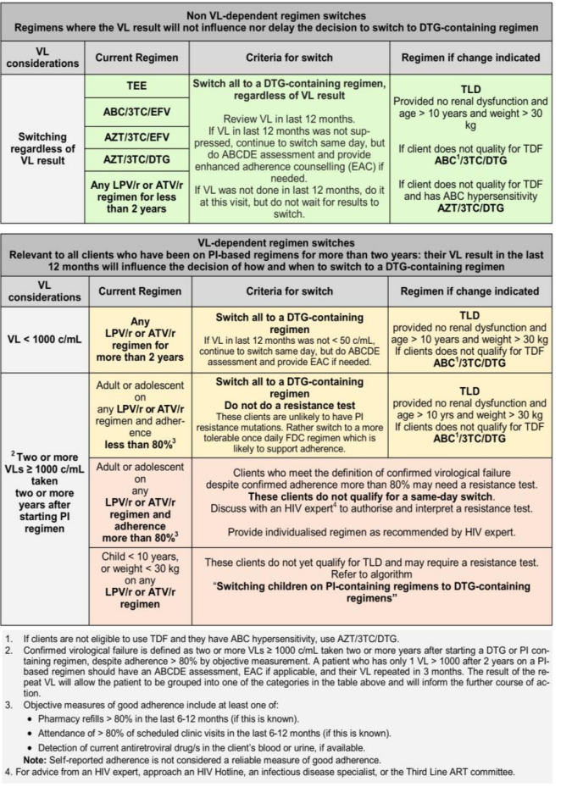
Figure 11.1: Switching existing clients to DTG-containing regimens (adopted from the NDoH 2023 ART Clinical Guidelines for the Management of HIV in Adults, Pregnancy and Breastfeeding, Adolescents, Children, Infants and Neonates.

Re-initating ART in patients who have interrupted treatment
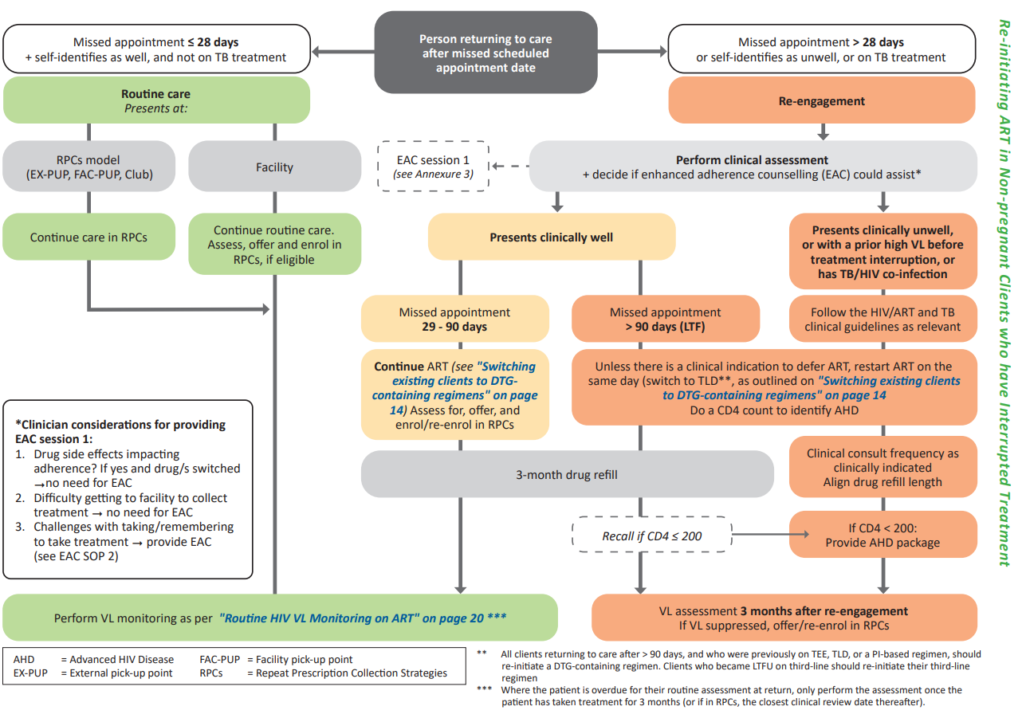
Figure 11.2: Management algorithm of a patient who returns to care after interrupting treatment. Incorporated from the NDoH 2023 ART Clinical Guidelines for the Management of HIV in Adults, Pregnancy and Breastfeeding, Adolescents, Children, Infants and Neonates.

MONITORING ON ART

Baseline evaluation | - WHO staging (See table above).  - Check CD4 count.  - If CD4 <200 cells/mm³:  - Check cryptococcal antigen (If positive, perform LP regardless of whether symptoms are present or not). CrAg testing is done reflexly on the CD4 sample if CD4 <100 cells/mm³. If patient’s CD4 is 100-199, a serum CrAg test must be ordered separately.  - Initiate cotrimoxazole prophylaxis (See Section 11.2.1: Cotrimoxazole prophylaxis).  - Screen for pregnancy or ask if planning to conceive.  - Screen for mental health, STIs and NCDs.  - Screen for TB using the WHO screening questionnaire (any one of cough, fever, night sweats, or weight loss).  - Sputum TB-NAAT* in all who can produce sputum, regardless of symptoms.  - Urine LAM for inpatients, or outpatients who are symptomatic if CD4 <200 or advanced HIV disease or current serious illness.  - If planning to use TDF: check creatinine (avoid TDF if eGFR <50 mL/minute).  - Haemoglobin  - Check HBsAg (if positive, TDF should form part of the regimen).  - Cervical cancer screening  *TB-NAAT: TB Nucleic Acid Amplification Test (e.g. GeneXpert Ultra MTB/RIF)
  LoE:IVb
  LoE:IIIb
  LoE:IIb
On ART | - Monitoring schedule has been adapted to minimise the number of visits required per annum.  - VL at 3 and 10 months after initiating ART and every 12 months thereafter, if virologically suppressed. Align timing with client’s scripting cycle.  - CD4 at 10 months after initiating ART (align with VL). Stop CD4 count monitoring when >200 cells/mm³ and virologically suppressed. If virological or clinical failure occurs, or if client returns >90 days after missing an appointment, then a CD4 count should be done as cotrimoxazole may need to be commenced/re-commenced. Repeat CD4 count every 6 months if VL remains ≥1000 copies/mL  - If on TDF: creatinine at month 3, month 10, and every 12 months thereafter. Align with VL monitoring schedule.  - If on AZT: FBC and differential count at 1 and 3 months after initiating AZT, then only if clinically indicated.  - ALT if symptoms of hepatitis develop.  - If on a protease inhibitor (PI): cholesterol and triglycerides at 3 months after initiating PI. If above acceptable range, do fasting cholesterol and TGs and if still above acceptable range, obtain expert advice.
Table 11.2: Monitoring on ART
HIV VIRAL LOAD MONITORING SCHEDULE

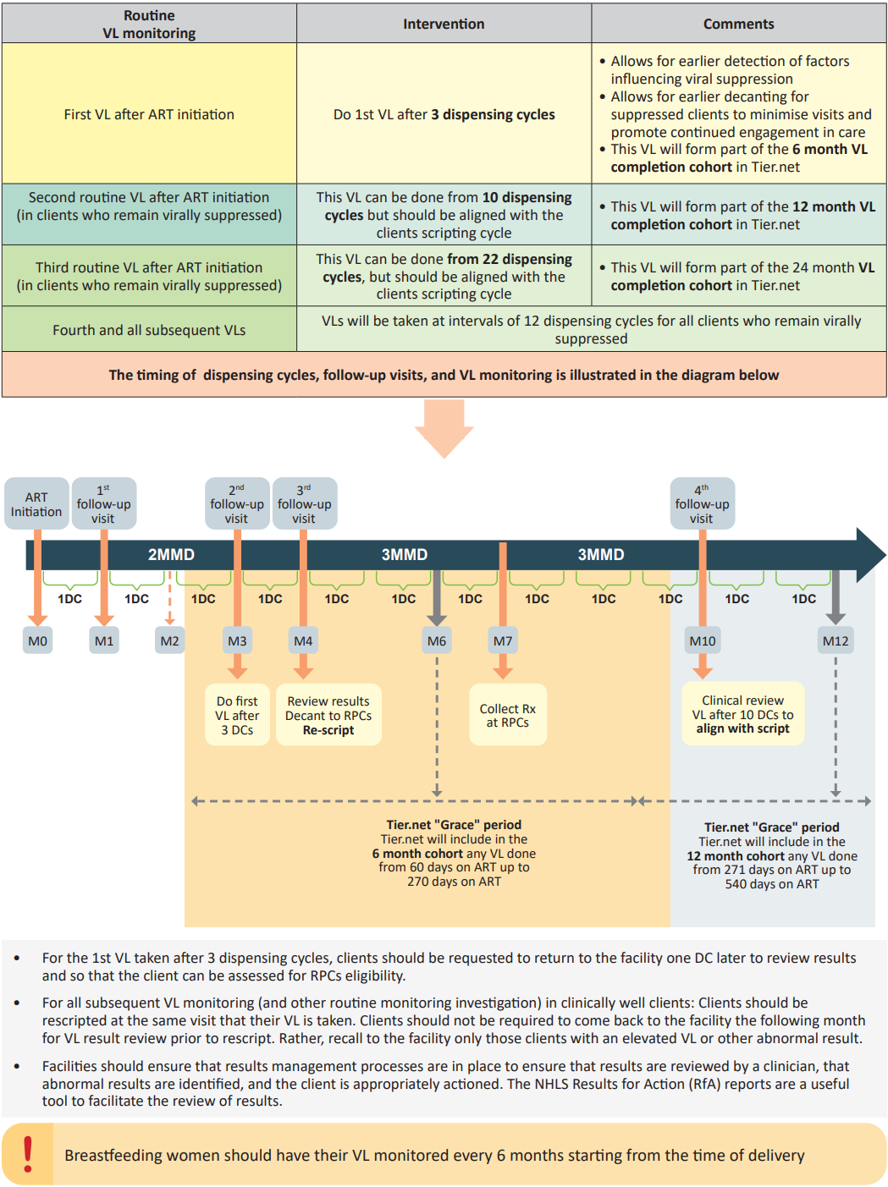
Figure 11.3: Incorporated from the NDoH 2023 ART Clinical Guidelines for the Management of HIV in Adults, Pregnancy and Breastfeeding, Adolescents, Children, Infants and Neonates.
DC: Dispensing cycle; MMD: Multi-month dispensing; RPCs: Repeat prescription collection strategies

ART: DOSING AND IMPORTANT ADVERSE EFFECTS
Generic name | Class | Usual dose | Renal adjusted dose | Important adverse drug reactions and timing
Dolutegravir (DTG) | InSTIs | 50 mg once daily | Dose adjustment not required. | - Hypersensitivity (rare, weeks).  - Insomnia (common).  - Headache (common).  - Other neuropsychiatric symptoms.  - Nausea, diarrhoea (common).  - Hepatitis (uncommon).  - Increase in serum creatinine (<30 mmol/L within the first few weeks of DTG initiation) due to inhibition of creatinine secretion by DTG; this is clinically insignificant as glomerular filtration rate is not reduced but will modestly affect eGFR which is determined using serum creatinine.
Tenofovir disoproxil fumarate (TDF) | NRTI | 300 mg daily | Avoid in renal impairment (eGFR <50 mL/min). | - Acute kidney injury (rare - weeks to months).  - Decline in eGFR (months to  years).  - Fanconi syndrome (rare – months to years).  - Reduced bone mineral density (months to years).
Abacavir (ABC) | NRTI | 600 mg daily | Dose adjustment not required. | - Hypersensitivity reaction (1 to 6 weeks): fever, rash, constitutional symptoms, gastrointestinal symptoms and respiratory symptoms.
Zidovudine (AZT) | NRTI | 300 mg  12 hourly | eGFR <10 mL/min:  300 mg daily | - Anaemia, neutropenia (weeks to months).  - Gastro-intestinal upset.  - Headache.  - Myopathy (rare).  - Hyperlactataemia / steatohepatitis (medium risk - months).  - Lipoatrophy (months to years).
Lamivudine (3TC) | NRTI | 300 mg daily  (or  150 mg 12  hourly) | eGFR 10-30 mL/min:  150 mg daily  eGFR <10 mL/min:  50 mg daily | - Anaemia due to pure red cell aplasia (rare).
Emtricitabine (FTC) | NRTI | 200 mg daily | eGFR 15-29 mL/min:  200 mg every 3 days  eGFR <15 mL/min:  200 mg every 4 days  Note: FTC is not available as a single-ingredient formulation. | - Palmar hyperpigmentation.  - Anaemia due to pure red cell aplasia (rare).
  LoE:IVb
Tenofovir alafenamide (TAF) | NRTI | 25 mg daily  If coformulated with FTC, avoid if eGFR <30 ml/min.  If used as a single agent, avoid if eGFR <15 ml/min and not on haemodialysis. |  | - Acute kidney injury (rare - weeks to months).  - Decline in eGFR (months to years)  - Fanconi syndrome (rare – months to years).  - Reduced bone mineral density (months to years).
Efavirenz (EFV) | NNRTI | 600 mg  at night | Dose adjustment not required. | - Central nervous system symptoms: vivid dreams, problems with concentration, confusion, mood disturbance, psychosis (days to weeks).  - Encephalopathy, often with cerebellar features (uncommon – months to years).  - Rash (1 to 6 weeks).  - Hepatitis (weeks to months).  - Gynaecomastia.
  LoE:IVb
Lopinavir/ ritonavir  (LPV/r) | Boosted PI | 400/100 mg 12-hourly  OR  800/200 mg daily (only if PI-naïve) | Dose adjustment not required. | - Gastrointestinal upset.  - Dyslipidaemia (weeks).  - Rash and/or hepatitis (1 to 6 weeks).
Atazanavir/ ritonavir (ATV/r) | Boosted PI | ATV 300 mg taken with ritonavir  100 mg daily | Dose adjustment not required. | - Unconjugated hyperbilirubinaemia (common, but benign).  - Dyslipidaemia (low risk).  - Hepatitis (rare - 1 to 6 weeks).  - Renal stones (uncommon).
Table 11.3: Dosing and important adverse effects associated with ART
The time-onset information with respect to adverse drug reactions (ADRs) serves as an estimate. Patients may present with ADRs with the onset deviating from that indicated in the table. InSTI: integrase strand transfer inhibitor; NRTI: nucleoside reverse transcriptase inhibitor; NNRTI: non-nucleoside reverse transcriptase inhibitor; PI: protease inhibitor.

LoE:IIIb

ART: DRUG-DRUG INTERACTIONS
Information can be accessed from:
- https://www.hiv-druginteractionslite.org/checker
- http://www.mic.uct.ac.za/ and download the ARV/EML interaction checker.
- Package inserts.

ART INTERACTIONS WITH RIFAMPICIN AND RECOMMENDATIONS FOR ADMINISTRATION
Class | ARV | Interaction with rifampicin | Dose of ARV with rifampicin
NRTI | 3TC/FTC/TDF/  AZT/ABC | No clinically significant pharmacokinetic interactions. | No dose adjustment required.
NNRTI | EFV | Non-significant change  (EFV concentrations may increase in patients who are genetic slow metabolisers of EFV and are on isoniazid (INH) which also inhibits EFV metabolism). | No dose adjustment required (600 mg at night).
InSTI | DTG | Significant reduction in concentration of DTG. | Increased dose frequency to 50 mg 12 hourly.  Note: Continue increased dose for 2 weeks after rifampicin is stopped, then decrease to usual dose.
PI | LPV/r | LPV plasma concentrations significantly decreased. | Double the dose of LPV/r to 800/200 mg 12-hourly.  Note: There is an increased risk of ALT/AST elevations and gastrointestinal disorders. Increase dose gradually over 1-2 weeks.  Adjusted dose should be continued for 2 weeks after rifampicin is stopped.
PI | All other PIs | Marked reduction in PI concentrations. | Do not prescribe concomitantly – replace rifampicin with rifabutin 150 mg daily.
Table 11.4: ART interactions with rifampicin and dose-adjustment recommendations

LoE:IIIb

In patients on atazanavir or darunavir, or if double dose LPV/r is not tolerated, replace rifampicin with rifabutin (doctor prescribed) – see Adult Hospital Level STGs and EML, Section 10.1: Antiretroviral therapy.
DRUG INTERACTIONS WITH DOLUTEGRAVIR
Interacting medicine | Effect of co-administration | Recommendation
Preparations containing polyvalent cations (Mg²⁺, Ca²⁺, Fe²⁺, Al³⁺, Zn²⁺)  Antacids  Sucralfate  Mineral supplements | Significant reduction in concentration of DTG. | Magnesium- and aluminum-containing preparations should be taken 6 hours before or 2 hours after DTG.  Calcium- and iron- containing preparations can be taken concomitantly with DTG when administered with food.  Note: Iron and calcium should be taken at least 4 hours apart from one another.
Anticonvulsants:  Carbamazepine  Phenobarbital  Phenytoin | Significant reduction in DTG concentration. | Avoid co-administration if possible.  Consider valproate or lamotrigine.  For carbamazepine:  Double DTG dose to 50 mg 12 hourly.
Metformin | May increase metformin concentration. | Metformin initiation:  Initiate metformin at a low dose (500 mg to 1000 mg total daily dose), titrating up as needed. Do not exceed 2 g daily.  DTG initiation:  If patient stabilised on metformin dose ≤ 2g daily, retain metformin dose and monitor for side effects.  If patient stabilised on >2 g daily, reduce dose of metformin to ≤2 g daily and monitor.  Patients with renal impairment:  Close monitoring of renal function required. Do not co-prescribe if eGFR <30 mL/min.
Rifampicin | Significant reduction in DTG concentration | Double DTG dose to 50 mg 12 hourly.

LoE:IIIb
Table 11.5: Drug interactions with DTG

DRUG INTERACTIONS WITH BOOSTED PIs
Interacting medicine | Effect of co-administration | Recommendation
Substrates of cytochrome P450 3A4 (e.g. most statins, calcium channel blockers, most SSRIs, most benzodiazepines) | Significant increase in concentrations of CYP3A4 substrates. | Avoid co-administration or use lower doses of CYP3A4 substrates (always consult interaction resources).
Anticonvulsants:  Carbamazepine Phenobarbital  Phenytoin | Significant reduction in concentration of PI. | Avoid co-administration.  Consider valproate or lamotrigine.
Proton pump inhibitors | Significant reduction in ATV concentration. | Avoid co-administration.
  LoE:IIIb
Rifampicin | Significant reduction in PI concentration. | Double LPV/r dose.  Note: There is an increased risk of ALT/AST elevations and gastrointestinal disorders. LPV/r dose should be gradually titrated upward over 1-2 weeks (e.g. 600/150 mg and then 800/200 mg).  Adjusted dose of LPV/r should be continued for 2 weeks after rifampicin is stopped.  The LPV/r can be switched back to ATV/r two weeks after completion of TB therapy.  If ATV/r or DVR/r is required, rifampicin must be replaced with dose-adjusted rifabutin (doctor prescribed) - see Adult Hospital Level STG Section 10.1: Antiretroviral therapy.
Table 11.6: Drug interactions with boosted PIs.

REFERRAL
Dolutegravir resistance demonstrated on resistance testing.

Opportunistic infections, prophylaxis in adults

Cotrimoxazole prophylaxis
Z29.2 + (B24)

DESCRIPTION
Primary prophylaxis reduces the probability of developing many infections, e.g.:
- pneumocystis pneumonia  - toxoplasmosis  - bacterial pneumonia | - bacteraemia  - cystoisosporiasis

Indications for primary prophylaxis:
LoE:IIIb
- WHO Clinical stage 3 or 4.
- CD4 count <200 cells/mm³.

MEDICINE TREATMENT

Prophylaxis
LoE:IIb
- Cotrimoxazole, oral, 160/800 mg daily.
Note:
- Once the CD4 >200 cells/mm³ discontinue prophylaxis. If the CD4 count was >200 cells/mm³ when cotrimoxazole was commenced (e.g. patients with TB) continue for 6 months. (See Section 17.3.4.2.4: Pneumocystis pneumonia, for secondary prophylaxis.)
LoE:IIIb
- Cotrimoxazole hypersensitivity is common and usually presents as a maculopapular rash. If there are systemic features or mucosal involvement associated with the use of cotrimoxazole, stop the medicine immediately and permanently, and refer the patient to hospital.

Tuberculosis preventive therapy (TPT)
Z29.2 + (B24)
PLHIV, at any CD4 count, are more susceptible to TB infection than HIV-uninfected people. TPT is an effective intervention for reducing the incidence of TB in PLHIV.

Eligibility
All adult PLHIV, irrespective of CD4 count and ART status.

Exclusions
- suspected or confirmed TB | - painful peripheral neuropathy
- liver disease | - alcohol use disorder
- previous MDR- or XDR-TB
Note:
- Exclude TB before initiating TPT by screening for the following:
- cough (any duration) | - weight loss
- cever | - night sweats
LoE:IIb
- Do not start TPT if any of the above symptoms are present. These patients require further investigation for active TB.
- Start TPT together with ARVs.
- TPT, e.g.:
- Isoniazid, oral, 300 mg daily for 12 months.

Adults and adolescents initiating a DTG-containing ART regimen:
- Isoniazid daily for 12 months is the preferred regimen.
For patients who are already virally suppressed on a DTG-based regimen:
- A weekly combination of isoniazid (900 mg if weight >30 kg) plus rifapentine (900 mg if weight >30 kg) for three months may be used.
- Do not use rifapentine-containing TPT in patients on protease inhibitor-based ART, or in women on hormonal contraceptives. [See the therapeutic interchange database for details regarding the rifapentine-containing TPT regimen].
- Educate patients on the symptoms of hepatotoxicity (nausea, vomiting, yellow eyes, brown urine, and pain in right upper quadrant) associated with TPT.
LoE:IIb
ADD
- Pyridoxine, oral, 25 mg once daily for the full duration of the TPT regimen.
- Instruct patient to present early if any of these symptoms arise.
- Follow patients up monthly for the first 3 months.

LoE:IIb
NOTE: For pregnant women:
- Defer TPT until after delivery.
- Ensure that routine screening against TB is conducted at each antenatal visit.

Opportunistic infections, treatment in adults

Aphthous ulcers in HIV infection
K12.0 + (B24)

DESCRIPTION
Painful ulcers in the mouth, except the gums, hard palate and dorsum of the tongue.
Minor ulcers (<1 cm diameter) usually heal within 2 weeks.
Major ulcers (>1 cm diameter) are very painful, often very deep, and persistant. Major ulcers generally resolve rapidly on ART.
Herpes simplex, histoplasmosis and mycobacteria may also present with major mucosal ulcers.

MEDICINE TREATMENT

Minor aphthous ulcers:
- Tetracaine 0.5 %, oral, topical, applied every 6 hours.
- Apply a thin layer on the affected areas only.

REFERRAL
Major aphthous ulcers for further diagnostic evaluation.

Candidiasis, oral
B20.4
See Section 1.2: Candidiasis, oral (thrush).
- Commence ART.

Candidiasis, oesophageal
B20.4

DESCRIPTION
Infection of the oesophagus with candida, a fungus that causes oral thrush.
Patients with oral thrush who also have pain or difficulty on swallowing may have oesophageal candidiasis. See Section 1.2: Candidiasis, oral (thrush).

GENERAL MEASURES
Maintain hydration.

MEDICINE TREATMENT
LoE:IIIb
- Fluconazole, oral, 200 mg daily for 14 days.

REFERRAL
- Inability to swallow.
- Frequent relapses.
- Poor response to fluconazole.

Cryptococcosis
B20.5 + B45.0-3/B45.7-9

DESCRIPTION
A life-threatening fungal infection caused by the fungus Cryptococcus. The fungi remain inactive unless a person’s immune system is weakened, such as in transplant recipients or persons with untreated HIV.

INVESTIGATIONS
- All ART-naïve adults and adolescents with CD4 <200 cells/mm³ should have a serum cryptococcal antigen (CrAg) test done (unless confirmed diagnosis of cryptococcal infection). This is performed as a reflex test on the patient’s CD4 sample if it is <100 cells/mm³. If the CD4 cell count is between 100 and 199, a separate sample should be sent for CrAg testing.
LoE:IIa
- All patients with a positive serum CrAg test should have a lumbar puncture (LP) to exclude cryptococcal meningitis. The CSF is tested for cryptococcal meningitis by CSF CrAg.

MEDICINE TREATMENT

If CSF CrAg positive:
Refer for liposomal amphotericin B, IV (induction phase) and monitoring of intracranial pressure symptoms - See Adult Hospital STGs and EML, Section 10.2.4: Cryptococcosis.
Patients may be down referred for consolidation and maintenance phase therapy; see below.

If there is any delay in performing LP, start oral fluconazole therapy:
LoE:IVb
- Adults: Fluconazole, oral, 1200 mg immediately.
- Children: 12 mg/kg to a maximum dose of 800 mg immediately

No symptoms present and CSF CrAg negative (LP):
Induction phase
LoE:IIIb
- Fluconazole, oral 1200 mg daily for 14 days.

Consolidation phase
Follow with:
- Fluconazole, oral, 800 mg daily for 8 weeks.

Maintenance phase
- Fluconazole, oral, 200 mg daily.
- Continue for at least 1 year provided that the CD4 count increases to >200 cells/mm³ on ART. If the CD4 count does not increase, continue treatment indefinitely.
LoE:IIIb

- Commence ART: See Section 11.1: Antiretroviral therapy, adults and adolescents.
- Cryptococcal meningitis: 4–6 weeks after starting antifungal therapy.
LoE:IIIb
- Asymptomatic cryptococcosis: No need to delay ART. ART can be started immediately.

CAUTION
- Fluconazole is potentially teratogenic when used during the 1st trimester, but pregnant women should be counselled that the benefits of fluconazole likely outweigh the risks in the management of cryptococcosis.
LoE:IIIb
- All pregnant women <20 weeks gestation exposed to fluconazole should have an ultrasound scan to detect congenital abnormalities.
LoE:IVb
- Although fluconazole is excreted into breast milk at concentrations similar to maternal plasma concentrations, the dose that the infant is exposed to with doses <400 mg is similar to the dose used in systemic treatment in infants. Even for higher doses, the benefits will likely outweigh the risks, though this can be discussed with a specialist.

REFERRAL
- If LP unavailable: Refer all serum CrAg positive patients to a facility where LP is available.
- If LP available:
  - Refer all patients that are CSF CrAg positive (cryptococcal meningitis).
  - Refer all symptomatic patients that are CSF CrAg negative (non-meningeal cryptococcosis).
- All patients with complications.

Diarrhoea, HIV-associated
B20.8 + (A07.2-3)

DESCRIPTION
Diarrhoea that persists for >2 weeks.
Often associated with wasting.
Diarrhoea persisting for 4 weeks is a WHO stage 3 condition (if there is weight loss or fever it is stage 4).
Send stool sample to look for ova, cysts and parasites in all cases.
Note: A negative stool specimen does not exclude Cryptosporidium. If Cryptosporidium infection is suspected, request specific laboratory testing for the parasite.

MEDICINE TREATMENT
If stool is negative for parasites or shows Cryptosporidium:
- Loperamide, oral, 2 mg as required.
- Maximum 8 mg daily.
- Commence ART.
If stool shows Isospora belli:
- Cotrimoxazole, oral, 320/1600 mg (4 single strength (80/400 mg) tablets) 12 hourly for 10 days.
- Followed by 160/800 mg (2 single strength (80/400 mg tablets) daily until CD4 >200 cells/mm³ on ART.
- Commence ART.

REFERRAL
Stool contains blood or mucus.

Eczema, seborrhoeic
See Section 5.8.3: Dermatitis, seborrhoeic.

Fungal nail infections
B20.5 + B35.1
This is common in PLHIV and can involve multiple nails. Treatment is not generally recommended because it is mostly of only cosmetic importance and therefore the risk of systemic therapy is not warranted. It generally resolves when patient is on ART.

Fungal skin infections
B20.5
See Section 5.5: Fungal infections of the skin.

Gingivitis, acute necrotising ulcerative
See Section 1.3.3: Necrotising periodontitis.

Herpes simplex ulcers, chronic
B20.3 + (B00.1-2)

DESCRIPTION
Painful ulcers due to herpes simplex virus, involving the skin around the anogenital area or in and around the mouth and nostrils in patients with advanced HIV infection. Ulcers persist for weeks and may be several centimetres in diameter.

GENERAL MEASURES
Keep affected areas clean with soap and water or diluted antiseptic solution.

MEDICINE TREATMENT
LoE: IIIb
- Antiviral (active against herpes simplex) e.g.:
- Aciclovir, oral, 400 mg 8 hourly for 7 days.
- Commence ART.

Pain:
- Paracetamol, oral, 500 mg to 1 g, 4 to 6 hourly as required (maximum of 4 g in 24 hours).
- Maximum dose: 15 mg/kg/dose.

REFERRAL
- No response to therapy.
- Frequent recurrences.

Herpes zoster (shingles)
B20.3 + (B02.0-3/B02.7-9)

DESCRIPTION
Painful vesicular rash in a dermatomal distribution, usually presenting as a band on one side of the body, due to recrudescence of the varicella-zoster virus that causes chickenpox. The surrounding skin is inflamed and the vesicles often contain cloudy fluid. Secondary bacterial infection is very uncommon.
The elderly and PLHIV are most affected.
Severe pain can occur after shingles has healed (post-herpetic neuralgia).
Shingles is less infectious than varicella (chickenpox) and isolation is not warranted.

MEDICINE TREATMENT

If fresh vesicles are present:
- Antiviral (active against herpes zoster) e.g.:
LoE:IIa
- Aciclovir, oral, 800 mg five times daily for 7 days (4 hourly missing the middle of the night dose).

If secondary infection is present:
ADD
- Flucloxacillin, oral, 500 mg 6 hourly for 5 days.

Pain:
- Paracetamol, oral, 500mg to 1 g, 4 to 6 hourly as required (maximum of 4 g in 24 hours).
- Maximum dose: 15 mg/kg/dose.

If inadequate pain relief:
ADD
- Tramadol, oral, 50 to 100 mg, 6 hourly as a starting dose. (Doctor prescribed.)
- May be increased to a maximum daily dose of 400 mg.
For prolonged pain occurring after shingles has healed (post-herpetic neuralgia), or if pain not responding to paracetamol and tramadol:
- Amitriptyline, oral, 25 mg at night.
- Increase dose to 50 mg after two weeks if needed.
- Increase to 75 mg after a further two weeks if needed.

REFERRAL
- Involvement of the eye.
- Disseminated disease (many vesicles extending beyond the main area).
- Features of meningitis (headache and neck stiffness).
- Severe post-herpetic neuralgia not responding to amitriptyline.

Papular pruritic eruption
L29.8

DESCRIPTION
Itchy inflamed papules at different stages of evolution. Healed lesions are often hyperpigmented. The itch is difficult to manage. May flare after starting ART, but generally improves as the CD4 count increases. It is essential to exclude scabies.

GENERAL MEASURES
Minimise exposure to insect bites, e.g. by regularly dipping pets.

MEDICINE TREATMENT
- Cetirizine, oral, 10 mg daily.
- Hydrocortisone 1%, topical cream, applied twice daily for 7 days.
- Apply sparingly to the face.

Pneumonia, bacterial
See Section 17.3: Respiratory infections.

Pneumonia, pneumocystis
See Section 17.3.4.2.4: Pneumocystis pneumonia.

Toxoplasmosis
B58 + (B20.8)
DESCRIPTION
Initial diagnosis should only be made at hospital level.

MEDICINE TREATMENT
- Cotrimoxazole, oral, 320/1600 mg 12 hourly for 4 weeks.
- Then 160/800 mg 12 hourly for 12 weeks.

Secondary prophylaxis
- Cotrimoxazole, oral 160/800 mg daily.
- Continue until the CD4 count has risen to >200 cells/mm³ on ART.
- Commence ART.

REFERRAL
Patients with suspected toxoplasmosis infection requiring further investigation to confirm diagnosis.

Tuberculosis (TB)
See Section 17.4: Pulmonary tuberculosis (TB).

HIV and kidney disease
N04.9/N05.9/N17.9 + (B24)

DESCRIPTION
Various forms of kidney disorders are described among PLHIV.
Early detection of HIV kidney disease may be beneficial in an attempt to protect the kidney from further disease progression and for adjusting the dose of relevant medicines (See Table 11.3: Dosing and important adverse effects associated with ART).
Screen all patients for renal disease at time of HIV diagnosis.
Patients at high risk or susceptible for HIV renal disease include:
- CD4 count <200 cells/mm³.
- History of nephrotoxic medications.
- Comorbidity such as diabetes mellitus, hypertension, or hepatitis C virus co-infection.

Screening for renal disease in HIV
- Tests should include:
  - Urine dipstix for haematuria and proteinuria.
  - Serum creatinine and eGFR.
- If there is no evidence of kidney disease at the initial evaluation, repeat screening annually.
- In patients receiving tenofovir, monitor creatinine/eGFR at month 3, month 10, and every 12 months thereafter. Align with VL monitoring schedule.

REFERRAL
- Patients with persistent significant proteinuria (1+ or more).
- Unexplained haematuria on 2 consecutive visits.
- Estimated eGFR <60 mL/min.

HIV infection in children (<10 years old)

DESCRIPTION
HIV is a retrovirus affecting immune cells, especially CD4 T-lymphocytes. In advanced HIV disease the body loses its ability to fight infections and this is characterised by organ damage, opportunistic infections, malignancies and very low CD4 counts.
In infants and children, most infection is transmitted from mother to child.
In adolescents and adults sexual spread is the usual cause.
Infants born of HIV-infected mothers may be:
- HIV-infected,
- HIV-exposed uninfected, or
- HIV-exposed, unknown infection status (at risk of becoming HIV-infected).

For the purpose of the ART guidelines:
- Children <10 years of age: follow the paediatric antiretroviral therapy (ART) guidelines.
LoE:IIIb
- Adolescents (10 to 19 years of age): follow the adult ART guidelines.

DIAGNOSIS IN CHILDREN
Testing must be done with counselling of parent/legal guardian/primary caregiver and, where appropriate, the child. The appropriate consent/assent should be obtained.

HIV TESTing IN CHILDREN
Age | Test | Note
HIV-exposed
Birth | HIV PCR | If the HIV PCR is positive at any time, confirm with a second HIV PCR.
10 weeks | HIV PCR
6 months | HIV PCR
6 weeks post-cessation of breastfeeding | Age appropriate testing:  <18 months: HIV PCR  ≥18 months: HIV rapid/ELISA
Universal screening
18 months | HIV rapid/ELISA | Perform on all children, unless known to be HIV infected.
HIV infected confirmatory test (any child with positive HIV test)
<24 months | HIV PCR | Between 18 and 24 months, the initial test will be HIV rapid/ELISA, but is confirmed with an HIV PCR.
≥24 month | HIV rapid/ELISA | Perform the second test on a different blood specimen with a test kit from a different manufacturer.
Possible/suspected symptomatic HIV infection
Any age if IMCI classification of:  - Pneumonia.  - Ear discharge (ever).  - Persistent diarrhoea in past 3 months.  - Not growing well, moderate acute malnutrition (MAM) or severe acute malnutrition (SAM).  - ≥ 2 enlarged glands of: neck, axilla or groin.  - Oral thrush.  - Parotid enlargement | Age appropriate testing:  <18 months: HIV PCR  ≥18 months: HIV rapid/ELISA
Other situations
- Parents request testing.  - Breastfed infant of a newly diagnosed HIV infected mother.  - Suspicion of sexual assault.  - Wet-nursed/breastfed infant fed by a woman of unknown or HIV-infected status (and repeat age-appropriate test 6 weeks later).  - Children considered for adoption or fostering. | Age appropriate testing:  <18 months: HIV PCR  ≥18 months: HIV rapid/ELISA

If an HIV PCR test is indeterminate or discordant, refer to the National Department of Health Guidelines for prevention of Mother to Child Transmission of Communicable Infections, 2023.
Table 11.7 HIV testing in children

WHO clinical staging of HIV and AIDS for infants and children
https://iris.who.int/bitstream/handle/10665/69058/WHO_HIV_2005.02.pdf
Adapted WHO clinical staging of HIV and AIDS for infants and children
For persons ≤15 years of age with confirmed laboratory evidence of HIV infection
Clinical Stage 1
- Asymptomatic,
- persistent generalised lymphadenopathy (PGL).
Clinical Stage 2
- unexplained persistent weight loss,
- hepatosplenomegaly,
- papular pruritic eruptions,
- extensive human papilloma virus infection,
- extensive molluscum contagiosum,
- fungal nail infections,
- recurrent oral ulcerations,
- lineal gingival erythema (LGE),
- unexplained persistent parotid enlargement,
- herpes zoster,
- recurrent or chronic RTIs, i.e.
  - otitis media,
  - otorrhoea,
  - sinusitis.
Clinical Stage 3
- moderate unexplained malnutrition (not adequately responding to standard therapy).
- unexplained persistent diarrhoea (14 days or more).
- unexplained persistent fever (above 37.5°C, intermittent or constant, for longer than one month).
- persistent oral candidiasis (after first 6-8 weeks of life).
- oral hairy leukoplakia.
- acute necrotising ulcerative gingivitis/periodontitis.
- lymph node TB.
- pulmonary TB.
- severe recurrent bacterial pneumonia.
- chronic HIV-associated lung disease including bronchiectasis.
- symptomatic lymphoid interstitial pneumonitis (LIP).
- unexplained anaemia (<8 g/dL), and or neutropaenia (<500/mm³) and/or thrombocytopaenia (<50 000/mm³) for more than one month.
Clinical Stage 4
- unexplained severe wasting, stunting or severe malnutrition not adequately responding to standard therapy.
- pneumocystis pneumonia.
- recurrent severe presumed bacterial infections, e.g.
- empyema | - bone or joint infection
- pyomyositis | - meningitis
- but excluding pneumonia,
- chronic herpes simplex infection; (orolabial or cutaneous of more than one month’s duration or visceral at any site),
- extrapulmonary TB,
- Kaposi’s sarcoma,
- oesophageal candidiasis (or candidiasis of trachea, bronchi or lungs),
- CNS toxoplasmosis (outside the neonatal period),
- HIV encephalopathy,
- CMV infection (CMV retinitis or infections of organs other than liver, spleen or lymph nodes; onset at age one month of more),
- extrapulmonary cryptococcosis including meningitis,
- any disseminated endemic mycosis, e.g.
  - extrapulmonary histoplasmosis,
  - coccidiomycosis,
  - chronic cryptosporidiosis,
  - chronic isosporiasis,
- disseminated non-tuberculous mycobacteria infection,
- HIV associated recto-vaginal fistula,
- cerebral or B cell non-Hodgkin lymphoma,
- progressive multifocal leukoencephalopathy (PML),
- HIV-associated cardiomyopathy or HIV-associated nephropathy.
Table 11.8: WHO clinical staging for infants and children

The HIV-exposed infant
Z20.6
DESCRIPTION
An HIV-exposed infant or child is one born to a mother living with HIV, until HIV infection in the infant or child is reliably excluded and the infant or child is no longer exposed through breastfeeding.

Transmission of HIV infection from mother to child may occur during pregnancy, during delivery or via breastfeeding. Transmission of infection from mother to child can be effectively prevented with a very high success rate by means of suppressing the mother’s VL and giving post-exposure prophylaxis to the infant, a strategy now known as Vertical Transmission Prevention (VTP; formerly termed Prevention of Mother to Child Transmission).

The risk of transmission from breast milk is low when the mother is virally suppressed. Ensure maternal VL monitoring is done every 6 months while breastfeeding and offer enhanced adherence counselling to ensure viral suppression is achieved and maintained.

When to test HIV-exposed children
- Birth (HIV PCR).
- For recommendations on when to perform additional tests, refer to the guidance on “HIV Testing in Children”. (See section above: HIV infection in children (<10 years old))

Feeding advice
- It is strongly recommended that exclusive breastfeeding be initiated within 1 hour of birth and continued for the first 6 months of life, after which the child's nutritional requirements will require the introduction of complementary foods in addition to breastfeeding.
- Women living with HIV should be fully supported for ART adherence during the breastfeeding period and thereafter.
- Women with a VL >50 copies/mL on TLD1 should continue breastfeeding while every effort is made to regain viral suppression. Their infants should receive high-risk prophylaxis during breastfeeding.
- The following may be indications to discontinue breastfeeding:
- Infants of mothers who are failing TLD2.
- Infants of mothers who are failing third-line PI-based treatment.
- Discuss appropriate feeding practices with the mother regarding the risks and benefits of continuing breastfeeding vs replacement feeding.
- The use of flash pasteurisation or ‘Pretoria’ pasteurisation to reduce HIV transmission is supported but may pose significant barriers to successful breast milk feeding due to the effort involved. For instance, it can be used as an interim measure during maternal mastitis.
NOTE: For the above,
- TLD1 = TLD as a first line ART regimen.
- TLD2 = TLD in patient who has failed a previous ART regimen.

MEDICINE TREATMENT

Mother
The VTP plan starts with initiation of ART in the mother (either pre or post conception). See Section 6.8: HIV in pregnancy.

Infant
Thereafter, the HIV-exposed infant may be classified into one of the following categories which determines the appropriate infant prophylaxis regimen:
- Low risk.
- High risk.
LoE:IIa
- Unknown risk, e.g. abandoned infant (manage as high risk).

Maternal VL | Risk profile | Prophylaxis | Comment
Maternal delivery VL as yet unknown at discharge from labour ward (results pending). | High-risk (until maternal delivery VL results become available). | Provide dual prophylaxis:  AZT at birth and then twice daily for 6 weeks.  NVP at birth and then daily for a minimum of 12 weeks. | All HIV-exposed infants will be considered high-risk until the final risk profile can be determined by the maternal delivery VL. If the maternal delivery VL result is not available at discharge from labour ward, review result at the 3 to 6 day postnatal visit and reclassify the infant accordingly.  Dispense a full 6 weeks supply of dual prophylaxis. Ask the mother to return with all medication at the 3 to 6 day postnatal visit.
Maternal delivery VL ≥ 50 copies/mL in a breastfeeding mother. | High-risk. | Provide dual prophylaxis:  AZT at birth and then twice daily for 6 weeks.  NVP at birth and then daily for a minimum of 12 weeks. | Do an ABCDE assessment and get the mother’s VL resuppressed as a matter of urgency. Stop infant NVP only after confirmation of maternal VL being <50 copies/mL, or until 4 weeks after cessation of all breastfeeding.
Maternal delivery VL ≥ 50 copies/mL in a mother who is exclusively formula feeding her infant from birth.* | High-risk. | Provide dual prophylaxis: AZT at birth and then twice daily for 6 weeks. NVP at birth and then daily for 6 weeks. | Do an ABCDE assessment and get the mother’s VL resuppressed as a matter of urgency.
Maternal delivery VL <50 copies/mL regardless of feeding choice. | Re-classify as low risk. | Change to low risk prophylaxis: NVP at birth and then daily for 6 weeks. | Affirm and encourage good adherence. Repeat maternal VL 6-monthly during breastfeeding.
*Non-breastfeeding mother diagnosed HIV-positive >72 hours after delivery: Do not start the infant on prophylaxis. Start maternal ART. Perform an HIV PCR test on the infant and, if positive, initiate ART. If negative, continue to monitor HIV risk and perform HIV testing as above.
Table 11.9: Risk categories for HIV-exposed infants
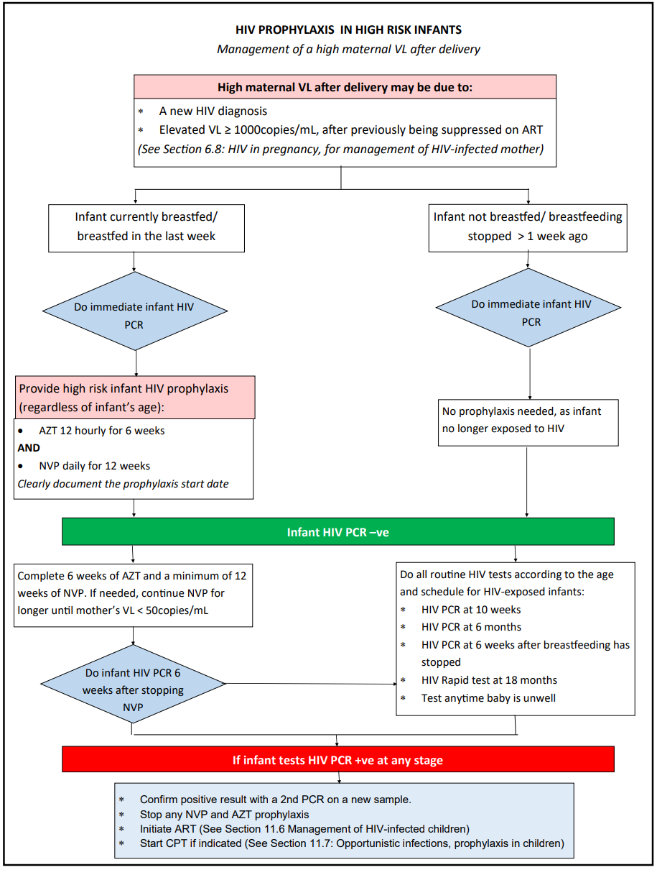
LoE:IIIb
Figure 11.4: HIV prophylaxis in HIV-exposed infant at high risk after delivery

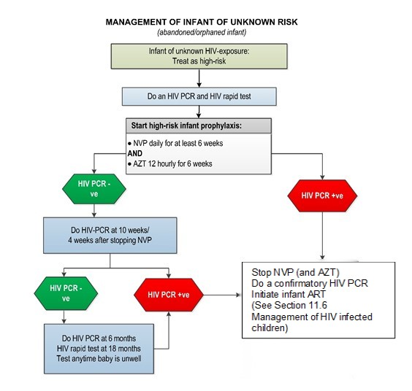
LoE:IIIb
Figure 11.5: Management of HIV-exposed infant of unknown risk

Non-breastfeeding mother diagnosed HIV positive >72 hours after delivery:
Do not start NVP. Perform an HIV PCR on infant and if positive initiate ART.

Infant VTP dosages:
Daily prophylaxis for 6 or 12 weeks administered to infants, as indicated above:
- Give 1st dose as soon as possible after birth.
- If baby vomits: Repeat dose once only.
- If infant HIV PCR is positive at any time, stop prophylactic ARV, confirm with 2nd PCR and initiate/refer for ART, while awaiting 2nd PCR result.
- Continue normal breastfeeding .

Nevirapine (NVP) and Zidovudine (AZT) doses for infant on VTP:
LoE:IIb

Newborns and infants:
- Nevirapine, oral, 4 mg/kg daily.
- Zidovudine, oral, 4mg/kg/dose 12 hourly.
 | Birth–6 weeks |  |  | 6 weeks – 6 months | 6 – 9 months | 9 – 24 months
 | 1.5-1.9 kg | 2.0– 2.49 kg | ≥ 2.5 kg | 6 weeks – 6 months | 6 – 9 months | 9 – 24 months
NVP (Daily) | 0.35 mL (0.35 mg) for 2 weeks  THEN  0.6 mL (0.6 mg) | 1 mL (10 mg) daily | 1.5 mL (15 mg) daily | 2 mL (20 mg) daily | 3 mL (30 mg) daily | 4 mL (40 mg) daily
AZT (Twice daily) | 2mg/kg for 2 weeks  THEN  3mg/kg for 2 weeks  THEN  4mg/kg | 1 mL (10 mg) twice daily | 1.5 mL (15 mg) twice daily | 6 mL (60 mg) twice daily | Children >6 months of age requiring AZT prophylaxis should use treatment doses.
Table 11.10: Dose bands for NVP and AZT in VTP.

REFERRAL
Mother declines infant ARV prophylaxis.

Management of HIV-infected children (<10 years)
B24

DESCRIPTION
HIV-infected child: An infant/child in whom HIV infection has been confirmed with two age-appropriate tests. See Section 11.5: The HIV-exposed infant.

GENERAL AND SUPPORTIVE MEASURES
- Identify a caregiver who can supervise the child’s treatment.
- Link the HIV interventions to the regular well infant visits/nutritional care. Ensure the road to health booklet is correctly completed and used to reflect and guide care.
- Counselling is a vital part of the successful care of children with HIV infection and their families. Specific matters requiring attention are:
  - The implications of the disease to the family.
  - Implications of treatment and understanding of the condition and its care.
  - The disclosure process within the family and extended family should be encouraged. Besides the caregiver, help from the family is often useful.
- Disclosure to the child as appropriate to age and maturity, with the parents’ support.
  - Find out what the child understands of their illness and what they would like to know.
  - Disclosure should be child-led in terms of information required, language used and educational/emotional readiness.
  - Anticipate the effects of disclosure on the child, family and other contacts such as friends and school colleagues.
  - Ensure that in disclosure, the child is constantly reassured of the parents’/caregivers’ love.

Treatment of mothers, caregivers and other family members:
- Always ask about the caregiver’s health, and the health of other family members.
- Ensure that mothers and other family members have timeous access to medical care including ART.
- Encourage breastfeeding in all mothers with HIV-infected children, with introduction of complementary foods from 6 months of age.
- At every visit ask about TB contacts and symptoms in children and their caregivers.

STANDARDISED NATIONAL MONITORING FOR INFANTS & CHILDREN WITH HIV
AT INITIAL DIAGNOSIS OF HIV | PURPOSE
Verify HIV status. | To ensure that national testing algorithm has been followed.
Document weight, height, head circumference (<2 years of age) and development. | To monitor growth and development.
Screen for TB symptoms. | To identify TB and HIV co-infection
Do CD4 count. | Determine eligibility for cotrimoxazole prophylaxis (CPT):  <1 year: CPT irrespective of CD4 count.  1 to 5 years: CPT if CD4 count <25% or WHO Stage 3 and 4.  >5 Years: CPT if CD4 count <200 cells/mm3 or WHO Stage 3 and 4.
Hb or FBC if available. | To detect anaemia or neutropaenia.
AT INITIATION OF ART (BASELINE) | PURPOSE
Hb or FBC. | If <8 g/dL: Manage appropriately.
CD4 count (if not performed in last 6 months). | Baseline assessment.
ALT (If jaundiced or on TB treatment). | To detect liver dysfunction.
ON ART | PURPOSE
Height, weight, head circumference (if child <2 years) and development. | To monitor growth and development.  Adjust dosing at each visit according to weight gain.
Clinical assessment including medicine-related adverse events. | To monitor response to ART and detect adverse effects.
CD4: At 1 year on ART, and then every 6 months until meets criteria to stop cotrimoxazole. Thereafter stop CD4 count monitoring if patient remains virologically supressed.  If not virologically supressed monitor CD4 count every 6 months. | To monitor response to ART.  Stop cotrimoxazole prophylaxis if indicated.
Viral load:  At month 3 on ART, after 12 months on ART, then every 12 months if virologically suppressed.  More frequent monitoring (3 to 6 monthly) recommended in patients with treatment failure. | To monitor viral response to ART.  To identify treatment failure and adherence problems.  For management of an elevated VL, see algorithm, below: Monitoring and management of viral loads.
Hb or FBC at months 3 and 6 if on AZT. Thereafter, repeat if clinically indicated | To identify AZT-related anaemia.
If on PI-based regimen:  Cholesterol + triglyceride at month 3. If above acceptable range, do fasting cholesterol and TGs; and if still above acceptable range consult with doctor/specialist. | To monitor for PI-related metabolic side effects.
LoE:IIIb
Table 11.11: Monitoring for infants and children with HIV on ART

MEDICINE TREATMENT

Prophylaxis for opportunistic infections
See Section 11.7: Opportunistic infections, prophylaxis in children.

Immunisation, deworming and vitamin A programme
- Continue deworming and vitamin A programme as in the HIV-uninfected child.
- Continue immunisation as per the SA-EPI (See Section 13.3: Vaccines for routine administration).

Nutritional support
Treat specific nutritional deficiencies appropriately.

Antiretroviral therapy
Initiation of ART in well infants shown to be PCR-positive should be carried out at PHC level.
The preparation of the child and family to start ART is critical to the success of the treatment. Failure to achieve adherence and understanding may lead to resistance and adversely affect the prognosis of the child.

Eligibility for ART
Clinical criteria
LoE:IIIb
- Confirmation of diagnosis of HIV infection, irrespective of CD4 count/percentage or WHO clinical stage.
AND
- No indications for deferral (e.g. major organ dysfunction). If medical contraindications are present, refer to hospital for rapid review and planning.

Social issues that must be addressed to ensure successful treatment
These are extremely important for success and impact on adherence. Social challenges should be overcome and not be barriers to care. Disclosure to another adult living in the same house is encouraged so that there is someone else who can assist with the child’s treatment. However, absence of disclosure should not preclude ART initiation.
- Mandatory component: At least one identifiable caregiver able to supervise the child and/or administer medication. All efforts should be made to ensure that the social circumstances of vulnerable children (e.g. orphans) be addressed to facilitate treatment.
- Adherence:
  - High levels of adherence are required for adequate virological response and prevention of viral resistance. This can be achieved with regular education and support.
  - All efforts to encourage this level of adherence should be made.
  - Viral load measurements are useful for monitoring adherence.
  - Sensitive, age-appropriate disclosure facilitates adherence.
- Mother and other family members should be assessed and treated.

Counselling before ART is initiated
The health care worker should ensure the caregiver/s understanding of HIV, ART and the importance of virological suppression and train caregivers on practical skills to adhere to ART.

ART regimens
- Treatment regimens are chosen according to age, weight, expected adverse effects, efficacy and prior antiretroviral exposure.
- Adjust the dosage of ART according to weight during follow up visits. Assess weight gain and need for adjustment at each visit.
- Do not change regimens or move to an alternative regimen, without clear guidance from a paediatric expert, as unnecessary loss of effective regimens can shorten life expectancy. Address adherence problems thoroughly before switching to an alternative regimen.
- Single medicine substitutions may only be made when medicine-specific adverse effects are encountered, on condition that virological suppression is documented and the matter is discussed with a practitioner experienced in child ART.

First-line ART regimens for infants and children:
ALD1: Clients on a DTG-containing regimen, having never failed a previous regimen (old ‘first-line’ terminology).
ALD2: Clients on a DTG-containing regimen, who have failed a previous regimen (old ‘second- line’ terminology).
ALD: abacavir, lamivudine, dolutegravir.

General ART comments
- Switch to tablets or capsules from pellets, syrups or solutions as soon as possible.
- Fixed-dose combinations are preferred to single agents.
- If available, use once daily dose regimens.

Side effects:
In patients being considered for an AZT-containing regimen, monitor for anaemia prior to initiation of ART.
A small proportion of patients initiated on ABC are at risk of abacavir hypersensitivity reaction, which presents with fever, rash and gastrointestinal disturbances. If this reaction is suspected, consult an expert.

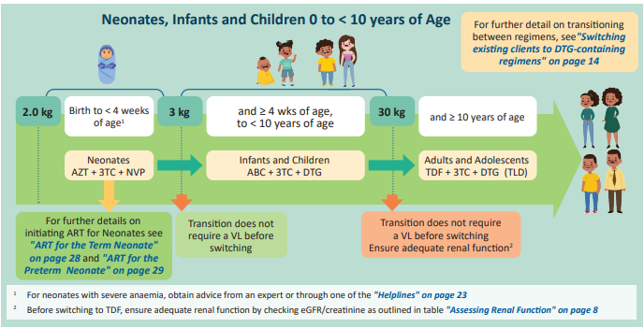
LoE:IIIb
Figure 11.6: First-line paediatric ART-switching algorithm for neonates/infants/children (adopted from the NDoH 2023 ART Clinical Guidelines for the Management of HIV in Adults, Pregnancy and Breastfeeding, Adolescents, Children, Infants and Neonates).

Transition from ABC/3TC/LPV/r to DTG based regimens
- Children <10 years or weight <30 kg
  - On PI based regimen for <2 years: switch to DTG based regimen (no VL required)
  - On PI based regimen for ≥2 years: review VL results, manage as per algorithm in figure 11.7.

For patients not eligible for transition to DTG based regimen
- Consider switching to ABC/3TC/LPV/r 4-in-1 formulation and repeating HIV VL in 3 months. If HIV VL <1000 copies/mL, change to ABC/3TC/DTG and if >1000 copies/mL, perform an HIV drug resistance test (DR).
- Perform an HIV DR if 4-in-1 formulation not available.
- If NRTI mutations on the HIV DR show:
  - No mutations or only M184V – switch to ABC/3TC/DTG.
  - M184V + other mutations – discuss with an experienced practitioner in child ARV medicine.

Switching children on PI-containing regimens to DTG regimens
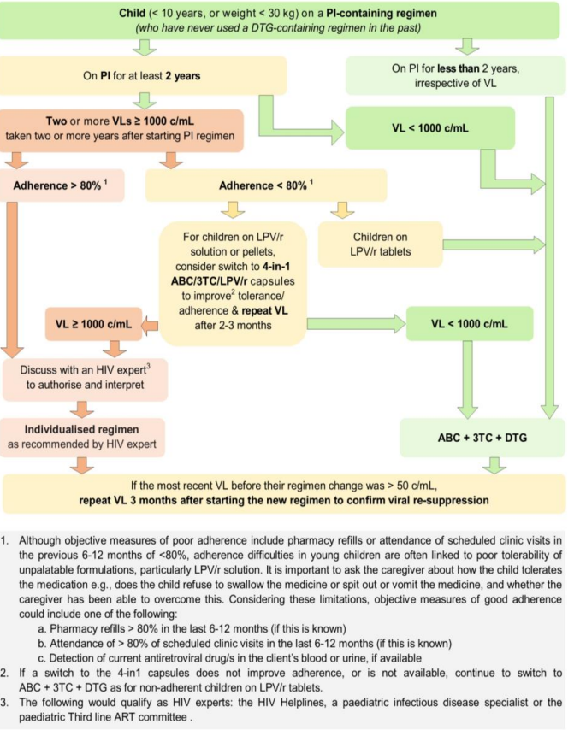
Figure 11.7: Switching children on PI-containing regimens to DTG regimens (adopted from the NDoH 2023 ART Clinical Guidelines for the Management of HIV in Adults, Pregnancy and Breastfeeding, Adolescents, Children, Infants and Neonates).

Treatment failure
The HIV viral load is the most sensitive method to detect failure of response to ART.

Virological failure can be defined as a measurable viral load despite optimal adherence and dosage over 4 months. Treatment failure is primarily defined by viral loads, as waiting for clinical or immunological failure increases the chances of increasing viral resistance to other available antiretroviral agents.
Poor adherence is the most common cause of treatment failure. Adherence issues should be assessed and then implement strategies to improve adherence.
*For guidance on the step-up adherence package, refer to the National adherence guidelines. https://www.nacosa.org.za/wp-content/uploads/2016/11/Integrated-Adherence-Guidelines-NDOH.pdf

Third-line (patients failing ALD2)
Discuss with expert

- Application forms for third-line antiretroviral therapy (patients failing ALD2) can be accessed at the following link: https://knowledgehub.health.gov.za/elibrary/third-line-antiretrovirals.
» Important information to assist in applying for third-line antiretrovirals can be found at https://knowledgehub.health.gov.za/elibrary/third-line-antiretrovirals.
LoE:IIIb
Applications can be emailed to TLART@health.gov.za.

Management of confirmed virological failure in adolescents on TLD
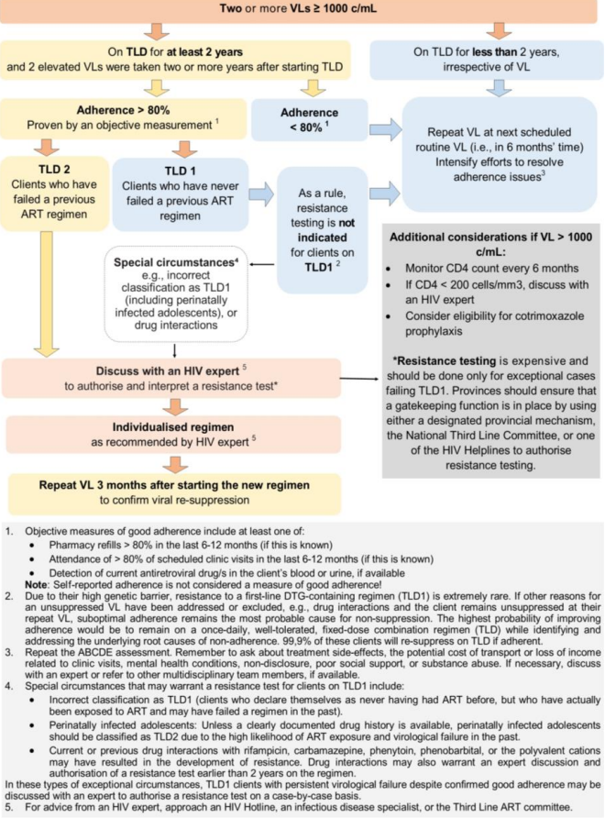
Figure 11.8: Management of confirmed virological failure in adolescents on TLD (adopted from the NDoH 2023 ART Clinical Guidelines for the Management of HIV in Adults, Pregnancy and Breastfeeding, Adolescents, Children, Infants and Neonates).TLD1 = TLD as a first line ART regimen and TLD2 = TLD in patient who has failed a previous ART regimen
Viral Load Monitoring for clients on TLD
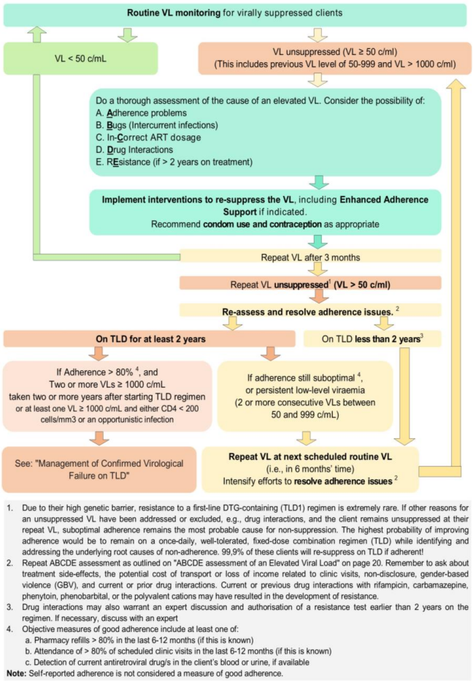
Figure 11.9: Viral load monitoring for clients on TLD (adopted from the NDoH 2023 ART Clinical Guidelines for the Management of HIV in Adults, Pregnancy and Breastfeeding, Adolescents, Children, Infants and Neonates).

ART dosing tables for infants and children

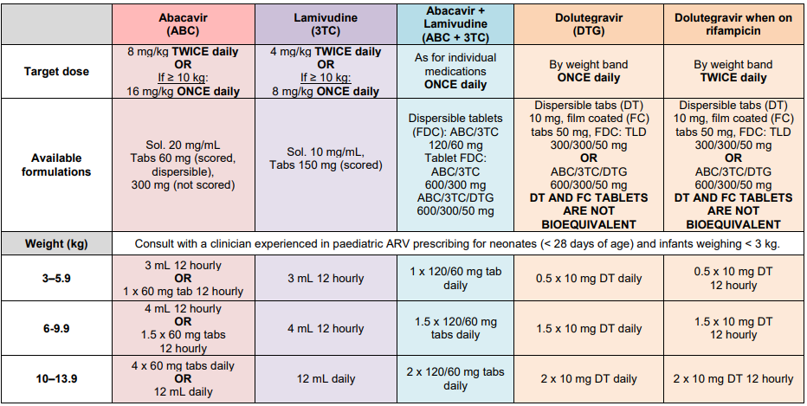
Table 11.12: ART dosing tables for infants and children (adopted from the NDoH 2023 ART Clinical Guidelines for the Management of HIV in Adults, Pregnancy and Breastfeeding, Adolescents, Children, Infants and Neonates).

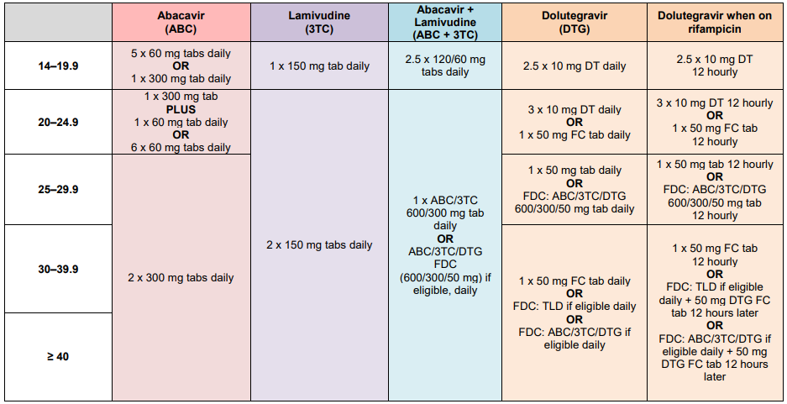
Table 11.12: ART dosing tables for infants and children (continued) (adopted from the NDoH 2023 ART Clinical Guidelines for the Management of HIV in Adults, Pregnancy and Breastfeeding, Adolescents, Children, Infants and Neonates).

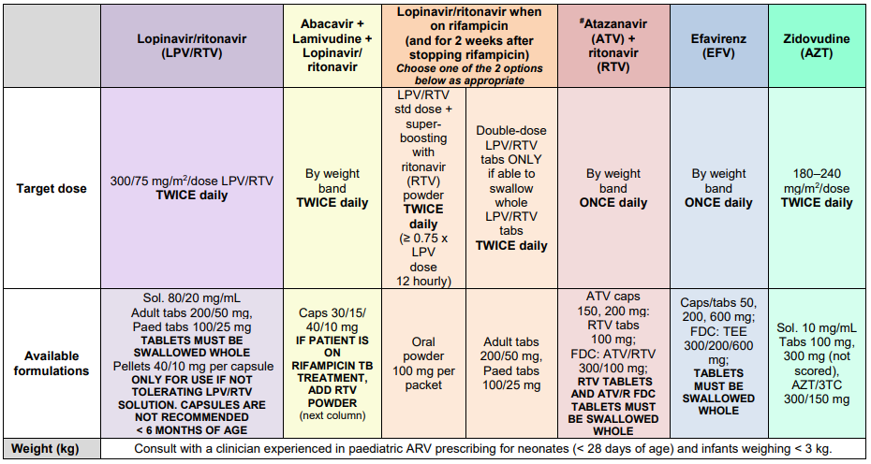
Table 11.12: ART dosing tables for infants and children (continued) (adopted from the NDoH 2023 ART Clinical Guidelines for the Management of HIV in Adults, Pregnancy and Breastfeeding, Adolescents, Children, Infants and Neonates).

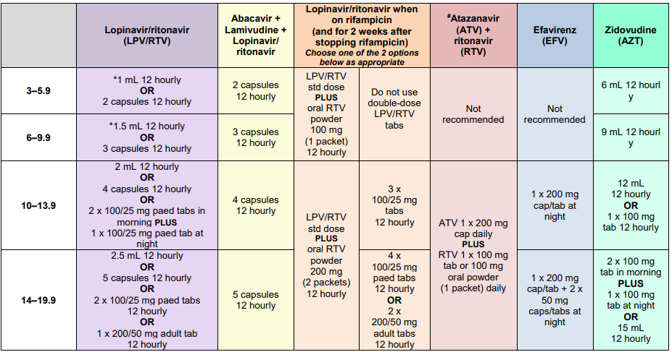
Table 11.12: ART dosing tables for infants and children (continued) (adopted from the NDoH 2023 ART Clinical Guidelines for the Management of HIV in Adults, Pregnancy and Breastfeeding, Adolescents, Children, Infants and Neonates).

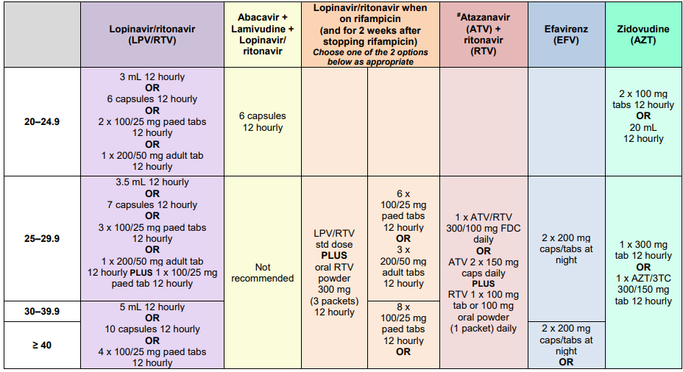
Table 11.12: ART dosing tables for infants and children (continued) (adopted from the NDoH 2023 ART Clinical Guidelines for the Management of HIV in Adults, Pregnancy and Breastfeeding, Adolescents, Children, Infants and Neonates).

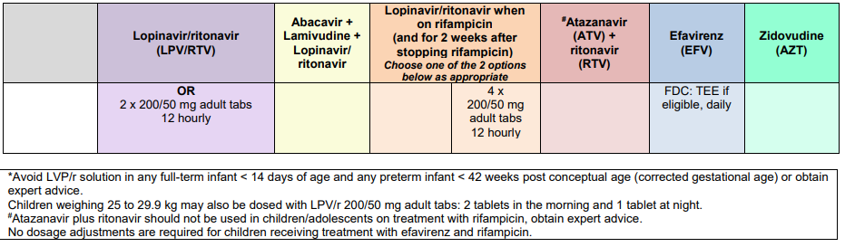 Table 11.12: ART dosing tables for infants and children (continued) (adopted from the NDoH 2023 ART Clinical Guidelines for the Management of HIV in Adults, Pregnancy and Breastfeeding, Adolescents, Children, Infants and Neonates).

Instructions to administer LPV/r pellets to children are:
- Hold the capsule at both ends and, twisting in opposite directions, pull apart to pour out the pellets inside the capsule.
- Add the pellets (from the required number of capsules) to a spoonful of food a little at a time. For example, porridge can be used (must be at room temperature)
- Do not stir, crush, or dissolve the pellets: rather sprinkle over the food.
- Use only a small amount of food, to ensure child can consume all the pellets. Discard food with pellets after 2 hours.
LoE:IIIb
- The capsule can be discarded with usual waste.

Opportunistic infections, prophylaxis in children
Z29.2 + (B24)
LoE:IIIb

Cotrimoxazole prophylaxis
Initiation
- All HIV-infected infants (<1 year), starting from 6 weeks of age.
- Any child 1–5 years of age with CD4 <25%, or WHO stage 3 and 4.
- Any child >5 years of age with CD4 count <200 cells/mm³, or WHO stage 3 and 4.

• Cotrimoxazole (sulfamethoxazole/trimethoprim), oral, once daily.
Recommended daily dosage by weight band | Dose of sulfamethoxazole/ trimethoprim | Suspension (200/40 mg per 5 mL) | Single strength tablet  (400/80 mg) | Double strength tablet  (800/160 mg )
3 to 5.9 kg | 100/20 mg | 2.5 mL | ¼ tablet | -
6 to 13.9 kg | 200/40 mg | 5 mL | ½ tablet | -
14 to 24.9 kg | 400/80 mg | 10 mL | 1 tablet | ½ tablet
25 kg | 800/160 mg | - | 2 tablets | 1 tablet

Table 11.13: Dose bands for cotrimoxazole

Discontinuation

Prophylaxis may be discontinued if the immune system is fully reconstituted on ART i.e.
Child >1 year of age, AND immune system shows signs of full reconstitution on two CD4 tests at least 3-6 months apart (regardless of clinical stage), i.e.:
Child 1-5 years of age: CD4 >25%.

Child >5 years of age: CD4 >200 cells/mm³.

TB prophylaxis
See Section 17.4.2.1: TB chemoprophylaxis/Isoniazid preventive therapy (IPT) in children.

Immunisation
Continue immunisation as per the SA-EPI (see Section 13.3: Vaccines for routine administration).

opportunistic infections, treatment in children

Candidiasis, oral (thrush), recurrent
B20.4

MEDICINE TREATMENT
- Nystatin suspension, oral, 100 000 IU/mL, 0.5 mL after each feed.
- Keep in contact with the affected area for as long as possible prior to swallowing.
- In the older child, ask child to swirl in the mouth, prior to swallowing.
- In the infant, advise caregiver to apply to front of the mouth and spread over the oral mucosa with a clean finger.
- Continue for 48 hours after resolution of symptoms.
If there is oral candidiasis and the child cannot swallow, this indicates the presence of oesophageal candidiasis. See Section 11.8.2: Candidiasis, oesophageal.

Candidiasis, oesophageal
B20.4

MEDICINE TREATMENT
- Fluconazole, oral, 6 mg/kg once daily for 21 days. See dosing table: Chapter 23.

Diarrhoea, hiv-associated
See Section 2.9: Diarrhoea.

Pneumonia
See Section 17.3.4: Pneumonia

Measles and chickenpox
Refer all patients.

Skin conditions
These are common and include scabies, seborrhoeic eczema and others.
See Chapter 5: Skin conditions.
If no response to care as directed in the chapter, refer.

Tuberculosis (TB)
A15.0-6/A15.7-9/A16.0-5/A16.7-9/A17.0-1/A17.8-9/A18.0-8/A19.0-2/A19.8-9 + B20.0

DESCRIPTION
TB and HIV are often comorbid conditions. Exclude TB in all patients before starting ART. See Section 17.4.2: Pulmonary tuberculosis, in children.
Re-evaluate the risk for TB and TB contact at each visit on history (including contact history) and clinical examination.
TB should be considered early in non-resolving pneumonias. At every follow up visit, ask about symptoms of cough, night sweats, fever, TB contacts and check for failure to thrive.
Refer early for diagnostic evaluation. If TB is suspected:
- Chest radiograph (CXR).
- GeneXpert on any relevant specimen including stool.
- Culture on respiratory or appropriate specimen.
- Urine-LAM. If no sample obtained, continue evaluation.

MEDICINE TREATMENT
TB prophylaxis Z29.2 + (B24)
Give TB prophylaxis to all HIV-infected children in whom no evidence of TB disease is present and who are:
- Exposed to a close contact with infectious pulmonary TB, or
- TST-positive (this test is only reliable the first time TPT is given).
- Isoniazid, oral, 10 mg/kg/dose once daily for 6 months.
- Maximum dose: 300 mg daily.
- See Section 17.4.2.1: TB chemoprophylaxis/Isoniazid preventive therapy (IPT) in children.
Repeat course if an HIV-infected patient, irrespective of age, is re-exposed to a TB contact at any point after completing TB treatment or prophylaxis.
Refer if patient has been exposed to a known MDR or XDR-TB source case or the contact case has failed standard TB treatment.

TB treatment
If the child is not yet on ART:
- TB treatment and ART can be started at the same time, with the exception of children with TB meningitis – start ART at 4 weeks regardless of CD4 count to avoid IRIS.
- Assess the child for possible disseminated TB disease.
- Be aware of the possibility of Immune Reconstitution Inflammatory Syndrome (IRIS).
If the child is already on ART:
- Commence TB treatment, considering possible drug interactions and the need for ART dosage adaptations.
If the child needs to take concomitant ART and rifampicin-containing treatment:
- Dolutegravir: use dolutegravir twice daily.
- Efavirenz: use the normal recommended dosage as per the dosing table.
- Abacavir and lamivudine: no adjustment of dosages.
- Lopinavir/ritonavir: refer to the dosage table for the ritonavir boosting doses.
- Avoid using double-dose lopinavir/ritonavir solution in young children. If ritonavir powder is not available, consult an expert.
- Give pyridoxine (vitamin B6) to all children on TB treatment and ART, to avoid development of peripheral neuropathy.

Developmental delay or deterioration

General Measures
Refer children with cognitive (learning problems) and motor delays for assesment and neurodevelopmental rehabilitation.

Anaemia
See Section 3.1: Anaemia.

HIV prevention

Pre-exposure prophylaxis (PrEP)
Z20.6 + Z29.2
Consult the most recent National Department of Health Guideline for PrEP eligibility criteria.

DESCRIPTION
Pre-exposure prophylaxis (PrEP) is the use of antiretroviral medicines by HIV-negative individuals before potential exposure to HIV to prevent them from acquiring HIV infection.
PrEP only protects against HIV infection; it does not offer protection against other STIs or pregnancy.
PrEP should be used as part of a package that also includes condoms; lubricants for anal sex; STI management; screening and management of intimate partner violence; sexual and reproductive health services; medical male circumcision; and HIV services, including counselling and testing, HIV management, ART, and PEP.
All individuals requesting PrEP should be assessed and initiated if elgible.

Individuals initiated on PrEP must meet the following criteria:
- HIV-negative.
- Willing and able to adhere to PrEP.
- Prepared to come for repeat HIV testing every 3 months if on oral PrEP or every 6 months if on injectable PrEP.
- No contra-indications to, or drug interactions with available PrEP options.
- No suspicion of acute HIV-infection (see clinical features, below).

Clinical features of acute HIV infection
Symptoms | Signs
Malaise, anorexia, myalgia, headache, sore throat, sore glands, rash | Fever, sweating, viral meningitis, generalised lymphadenopathy, hepatosplenomegaly, pharyngitis, truncal rash, orogenital herpetiform ulceration, oral/oesophageal candidiasis, cervical adenopathy

CONTRAINDICATIONS TO PrEP
- Pre-existing HIV infection or unknown HIV status.
- Young women/men <35 kg or <15 years of age who are not Tanner stage 3 (sexual maturity) or greater.

Contraindications specific to PrEP options
Oral PrEP (tenofovir/emtricitabine (TDF+FTC)) | Injectable PrEP  (lenacapavir (LEN))
- Estimated creatinine clearance or eGFR <60 mL/min.  - Use of nephrotoxic medicines e.g. aminoglycosides.  - Unwilling or unable to adhere to daily oral PrEP. | - Estimated creatinine clearance or eGFR <15 mL/min or on renal replacement therapy.  - Severe hepatic impairment (Child-Pugh Class C).  - Unwilling or unable to adhere to 6 monthly injectable PrEP.

SCREENING INVESTIGATIONS BEFORE STARTING PrEP

Investigation | Screen applicable |  | Purpose | Action
Investigation | Oral PrEP | Injectable  PrEP | Purpose | Action
HIV test  (using algorithm in the HTS guidelines*) | Yes | Yes | Assessment of HIV status. | If HIV-negative: consider PrEP  If HIV-positive: Link to treatment and care services.
Estimated creatinine clearance  (eGFR) | Yes | No | To identify pre-existing renal disease. | Do not initiate oral PrEP if creatinine clearance/eGFR <60 mL/min. Repeat creatinine clearance two weeks after baseline screen if baseline eGFR < 60mL/min. If renal function returns to normal and other PrEP criteria are met, oral PrEP may be initiated. Refer for further investigation if renal function remains abnormal - injectable PrEP may be considered if eGFR ≥ 15mL/min.  60mL/min>eGFR >15mL/min
Hepatitis B surface antigen (HBsAg) | Yes | No but may screen for hepatitis B once injectable PrEP commenced | To caution those with hepatitis B infection of risk of hepatitis flare upon discontinuation of oral PrEP.  Hepatitis flare not identified as a risk with lenacapavir. | Assess eligibility for vaccination if available (see table below).  If HBsAg-positive, refer to specialist.
Urine pregnancy test | Yes | Yes | To identify if pregnant. | Provide counselling covering risk of HIV infection during pregnancy and benefits of taking PrEP.
RPR | Yes | Yes | To diagnose syphilis infection for treatment. | Manage according to STI guidelines.
Syndromic STI screening | Yes | Yes | To diagnose and treat STI. | Manage according to STI guidelines.
Table 11.13: Screening investigations before starting PrEP
*HIV Testing Services guidelines
Note:
- If symptoms or signs of acute HIV infection are present, PrEP should be postponed until symptoms subside, and a repeat rapid HIV test after 4 weeks remains negative.
- TDF + FTC is active against hepatitis B (HBV) infection. HBV infection is not a contra-indication to PrEP, but will require LFT monitoring in patients on oral PrEP. Discontinuation of TDF + FTC in patients with HBV requires referral to a specialist because of a risk of a hepatitis flare.

Hepatitis B immune status and PrEP eligibility
Hepatitis B surface antigen (HBsAg) | Hepatitis B surface antibody (HBsAb) | Action
Negative (-) | Negative (-) | Start PrEP: TDF+FTC or lenacapavir may be offered  Vaccinate with Hep B vaccine concurrently if available.
Negative (-) | Positive (+) | Start PrEP: TDF+FTC or lenacapavir may be offered  No Hep B vaccine needed
Positive (+) | N/A | Start PrEP: TDF+FTC or lenacapavir may be offered.  Refer for HBV evaluation and monitoring of liver function.
Table 11.14: PrEP eligibility determined by hepatitis B immune status
Note:
- PrEP users with chronic hepatitis B infection who develop abnormal liver function tests should be referred for assessment.

PrEP follow up and monitoring
Activity | Frequency
Confirmation of HIV-negative status | Oral Prep: At 1 month, then every 3 months.  Injectable PrEP: At 1 month then every 6 months
Address side effects | Every visit.
Adherence counselling | Every visit.
Estimated creatinine clearance | Frequency dependant on pregnancy status, age and co-morbidity:
  Age/  pregnant | Co-morbidity | Creatinine
  <30 years | None | n/a
  30–49 years | None | Baseline
  <50 years | Diabetes/ hypertension | Baseline, annually
  ≥ 50 years | None | Baseline
  ≥ 50 years | Diabetes/ hypertension | Baseline, annually
  Pregnant | n/a | Baseline, 3 & 6 months
STI screening and treatment | Every visit.
PrEP supply | TDF+FTC: 1 month supply, then 3 monthly supply.  LEN:.Loading dose tablets: Day 1 tablets to be administered during clinic visit with supply for Day 2. Injections to be administered by healthcare staff every 6 months.
Behavioural sexual risk reduction counselling | Every visit.
Table 11.15: Monitoring of person(s) on PrEP

PREP REGIMENS AND SAFETY
LoE:Ia

ORAL PREp (TDF-FTC) REGIMEN
A fixed dose combination formulation of:
LoE:IVb
- Tenofovir disoproxil fumarate (TDF), oral, 300 mg daily.
AND
- Emtricitabine, oral, 200 mg daily.
LoE:IIIb
Note: To reach adequate protective levels in tissues, 7 days of daily dosing are required. Individuals should be counselled that additional barrier protection should be used until therapeutic levels achieved.

SAFETY

Relevant medicine interaction information with TDF + FTC combination
Medicine | Interaction information | Advise
Standard TB medicines | No interaction. | No need for dose adjustments.
Hormonal contraception | No interaction. | Hormonal contraception does not affect PrEP effectiveness, nor does PrEP affect hormonal contraceptive effectiveness.
Nephrotoxic medicines | Increase risk of renal side effects. | Avoid daily oral PrEP regimen.  Advise other prevention methods or consider injectable PrEP regimen.
Table 11.16: Oral PrEP drug interactions

Side effects of TDF + FTC combination
Major | Renal toxicity, decreased bone mineral density, extremely small risk of lactic acidosis and hepatic steatosis or steatohepatitis.
Minor | Gastrointestinal symptoms (diarrhoea, nausea, vomiting and flatulence), unintentional weight loss.
Table 11.17: Side effects of oral PrEP
Note:
- Minor side effects are relatively common (approximately 1 in 10 individuals in the first 1 to 2 months).
- Mild and self-limiting; do not require discontinuation.
- Renal toxicity and decreased bone mineral density usually reversible upon stopping TDF + FTC.

INJECTABLE PREP (LENACAPAVIR) REGIMEN
Initiation  Day 1 | - LEN, subcutaneous injection, 927 mg (2 X 1.5 mL injections)  AND  - LEN, oral, 600 mg (2 X 300 mg tablets)
Initiation  Day 2 | - LEN, oral, 600 mg (2 X 300 mg tablets)  - Do not take the Day 1 and Day 2 oral doses on the same day.
Continuation | - LEN, subcutaneous injection, 927 mg (2 X 1.5 mL injections) every six months or 26 weeks from the last injection.
Table 11.18: Dose regimen for initiating LEN as PrEP

Management of missed doses of LEN

Initiation phase - missed oral dose on Day 2
- LEN, oral, 600 mg (2 X 300 mg tablets), take as soon as possible.

Continuation phase – delayed injection
Time since last injection | Dosage recommendation
26-28 weeks | - LEN, oral, 300 mg (1 X 300 mg tablet) as a single dose  AND  - LEN, subcutaneous injection, 927 mg (2 X 1.5mL injections).  - Administer injection on same day as single oral dose.  - Continue with LEN injection every six months or 26 weeks from the last injection.
› 28 weeks | Reinitiate LEN as per table 11.18 above  - Reassess if injectable PrEP still suitable for the client.  - Confirm HIV status is still negative.
Table 11.19: Management of injection delays during continuation phase

SAFETY
Some common drug interactions with lenacapavir are listed below. For more comprehensive information on drug interactions, see https://www.hiv-druginteractions.org/checker.
Medicine groups | Interaction information | Recommendation
Standard TB medicines:  - Rifabutin  - Rifampicin  - Rifapentine | Potential interaction | Use oral PrEP instead until TB treatment completed.
Hormonal contraception | No interaction. | No dose adjustments required
Anticonvulsants:  - Carbamazepine  - Phenobarbital  - Phenytoin | Potential interaction | Refer to doctor for switching to alternative anticonvulsant treatment.
Illicit/recreational drug use  - Ketamine | Potential interaction | LEN may increase ketamine-related effects such as respiration depression and hallucinations.  Avoid use of ketamine
Erectile dysfunction  - Sildenafil  - Tadalafil  - Vardenafil | Potential interaction | LEN may potentiate the effects of erectile dysfunction medicines.  Avoid concomitant use of erectile dysfunction medicines.
Table 11.20: LEN drug interactions
Note:
- Due to the long half-life of injectable lenacapavir, drug interactions may be significant for up to 9 months following subcutaneous injection.

Side effects of LEN
Major | Injection site reactions, including necrosis and ulcer (often linked to improper administration) , headache, nausea
Minor | Dizziness, vomiting, diarrhoea
Table 11.21: Side effects of LEN
Note:
- Major side effects reported in at least 5% (approximately 5 in 100 individuals in the PURPOSE 1 and/or 2 studies).
- For individuals who may need to switch from LEN to oral PrEP, initiate oral PrEP within 28 weeks of the last LEN injection.

STOPPING PREP
PrEP should be stopped if individual:
- Tests HIV-positive.
- Develops renal disease (for oral PrEP: eGFR < 60mL/min and injectable PrEP eGFR < 15mL/min)
- Is non-adherent to PrEP.
- Does not need or want PrEP.
- No longer meets eligibility criteria.
- Presents with safety concerns where the risks of PrEP use outweigh potential benefit.

Note:
- Continue oral PrEP for 7 days after the last potential HIV exposure.
- Patients with chronic HBV may experience a hepatitis flare on discontinuation of oral PrEP.
- Injectable lenacapvir has an extended washout period and drug levels decline slowly during the tail period. During the tail period, protection against HIV diminishes although the potential for drug interactions remains.

REFERRAL
- HBsAg-positive.
- Discontinuation of TDF + FTC in patients with HBV.

Figure 11.10: PrEP initiation algorithm

Post exposure prophylaxis
Is oka Section 21.3.6: Post exposure Prophylaxis (PEP).

Side effects and complications of ART
Refer to the Adult Hospital Level STGs and EML: Section 10.1.1 Management of selected antiretroviral adverse drug reactions, and consult with an infectious disease specialist as required.

Immune reconstitution inflammatory syndrome (IRIS)
D89.3 + (Y41.5 + B24)

DESCRIPTION
Clinical deterioration can occur after starting ART due an improvement in the immune system response to organisms already causing infection, e.g.
- M. bovis (BCG).
- M. tuberculosis (MTB).
There are 2 types of IRIS:
- Unmasking: when a previously unsuspected condition becomes manifest.
- Paradoxical: known condition on appropriate treatment becomes worse.

DIAGNOSTIC CRITERIA
- Exclude other active or inadequately treated diseases (including DR-TB).
- Presentation:
  - Usually during the first 6 weeks after starting ART.
  - Depends on the causative organism and the organ system involved, e.g. TB presents with fever, lymphadenopathy, worsening of the original tuberculous lesion, and/or deteriorating chest radiographic manifestations such as miliary pattern or pleural effusion.

REFERRAL
All patients.

South African National Department of Health. 2023 Antiretroviral Therapy Clinical Guidelines for the Management of HIV in Adults, Pregnancy and Breastfeeding, Adolescents, Children, Infants and Neonates. April 2023.
Eligibility for ART: INSIGHT START Study Group, Lundgren JD, Babiker AG, Gordin F, Emery S, Grund B, Sharma S, Avihingsanon A, Cooper DA, Fätkenheuer G, Llibre JM, Molina JM, Munderi P, Schechter M, Wood R, Klingman KL, Collins S, Lane HC, Phillips AN, Neaton JD. Initiation of Antiretroviral Therapy in Early Asymptomatic HIV Infection. N Engl J Med. 2015 Aug 27;373(9):795-807. http://www.ncbi.nlm.nih.gov/pubmed/26192873 Eligibility for ART: TEMPRANO ANRS 12136 Study Group. A Trial of Early Antiretrovirals and Isoniazid Preventive Therapy in Africa. N Engl J Med. 2015 Aug 27;373(9):808-22. http://www.ncbi.nlm.nih.gov/pubmed/26193126 Eligibility for ART- Immediate initiation of ART: Rosen S, Maskew M, Fox MP, Nyoni C, Mongwenyana C, Malete G, Sanne I, Bokaba D, Sauls C, Rohr J, Long L. Initiating Antiretroviral Therapy for HIV at a Patient's First Clinic Visit: The RapIT Randomized Controlled Trial. PLoS Med. 2016 May 10;13(5):e1002015. https://www.ncbi.nlm.nih.gov/pubmed/27163694 Eligibility for ART- Immediate initiation of ART: National Department of Health: National Consolidated Guidelines for the Management of HIV in Adults, Adolescents, Children and Infants and Prevention of Mother-to-Child Transmission, June 2020. https://www.knowledgehub.org.za/elibrary/national-consolidated-guidelines-management-hiv-adults-adolescents-children-and-infants
Immediate initiation of ART, pregnant and breastfeeding women: National Department of Health: Affordable Medicines, EDP-Adult Hospital level. Medicine Review: Dolutegravir in pregnant women and women of child-bearing potential (WOCP), 17 June 2021. https://www.knowledgehub.org.za/content/standard-treatment-guidelines-and-essential-medicines-list Immediate initiation of ART, pregnant and breastfeeding women: WHO. Consolidated guidelines on HIV prevention, testing, treatment, service delivery and monitoring: recommendations for a public health approach, July 2021. https://www.who.int/publications/i/item/9789240031593
Timing of ART initiation (pulmonary TB): Uthman OA, Okwundu C, Gbenga K, Volmink J, Dowdy D, Zumla A,Nachega JB. Optimal Timing of Antiretroviral Therapy Initiation for HIV-Infected Adults With Newly Diagnosed Pulmonary Tuberculosis: A Systematic Review and Meta-analysis. Ann Intern Med. 2015 Jul 7;163(1):32-9.http://www.ncbi.nlm.nih.gov/pubmed/26148280
Timing of ART initiation (tuberculous meningitis): Török ME, Yen NT, Chau TT, Mai NT, Phu NH, Mai PP, Dung NT, Chau NV, Bang ND, Tien NA, Minh NH, Hien NQ, Thai PV, Dong DT, Anh do TT, Thoa NT, Hai NN, Lan NN, Lan NT, Quy HT, Dung NH, Hien TT, Chinh NT, Simmons CP, de Jong M, Wolbers M, Farrar JJ. Timing of initiation of antiretroviral therapy in human immunodeficiency virus (HIV)--associated tuberculous meningitis. Clin Infect Dis. 2011 Jun;52(11):1374-83. http://www.ncbi.nlm.nih.gov/pubmed/21596680
Timing of ART initiation (cryptococcal meningitis): Eshun-Wilson I, Okwen MP, Richardson M, Bicanic T. Early versus delayed antiretroviral treatment in HIV-positive people with cryptococcal meningitis. Cochrane Database Syst Rev. 2018 Jul 24;7(7):CD009012. https://pubmed.ncbi.nlm.nih.gov/30039850/ Timing of ART initiation (cryptococcal meningitis): National Department of Health: National Consolidated Guidelines for the Management of HIV in Adults, Adolescents, Children and Infants and Prevention of Mother-to-Child Transmission, June 2020. https://www.knowledgehub.org.za/elibrary/national-consolidated-guidelines-management-hiv-adults-adolescents-children-and-infants Timing of ART initiation (cryptococcal meningitis): WHO. Consolidated guidelines on HIV prevention, testing, treatment, service delivery and monitoring: recommendations for a public health approach, July 2021. https://www.who.int/publications/i/item/9789240031593
Timing of ART initiation (asymptomatic cryptococcosis): Govender NP, Meintjes G, Mangena P, Nel J, Potgieter S, Reddy D, Rabie H, et al. Southern African HIV Clinicians Society guideline for the prevention, diagnosis and management of cryptococcal disease among HIV-infected persons: 2019 update. South Afr J HIV Med. 2019 Nov 8;20(1):1030. https://pubmed.ncbi.nlm.nih.gov/32201629/
Psychosocial indicators of readiness for ART: WHO. Consolidated guidelines on HIV prevention, testing, treatment, service delivery and monitoring: recommendations for a public health approach, July 2021. https://www.who.int/publications/i/item/9789240031593
Dolutegravir, oral (first-line ART): National Department of Health: Affordable Medicines, EDP-Adult Hospital level. Medicine Review: Dolutegravir in HIV‐infected patients commencing first‐line antiretroviral therapy, updated 27 July 2021 (including addendum of use of dolutegravir with rifampicin). https://www.knowledgehub.org.za/content/standard-treatment-guidelines-and-essential-medicines-list Dolutegravir, oral (first-line ART): Rutherford GW, Horvath H. Dolutegravir Plus Two Nucleoside Reverse Transcriptase Inhibitors versus Efavirenz Plus Two Nucleoside Reverse Transcriptase Inhibitors As Initial Antiretroviral Therapy for People with HIV: A Systematic Review. PLoS One. 2016 Oct 13;11(10):e0162775. https://www.ncbi.nlm.nih.gov/pubmed/27736859 Dolutegravir, oral (first-line ART): South African National Department of Health. 2023 Antiretroviral Therapy Clinical Guidelines for the Management of HIV in Adults, Pregnancy and Breastfeeding, Adolescents, Children, Infants and Neonates. April 2023.
Dolutegravir, oral (first-line ART in pregnancy/ WOCP): National Department of Health: Affordable Medicines, EDP-Adult Hospital level. Medicine Review: Dolutegravir in pregnant women and women of child-bearing potential (WOCP), 17 June 2021. https://www.knowledgehub.org.za/content/standard-treatment-guidelines-and-essential-medicines-list Dolutegravir, oral (risk of NTDs): National Department of Health. Notice: Updated guidance of dolutegravir in pregnancy, 29 June 2021 (Reference: 2021/06/29/EDP/01). https://www.knowledgehub.org.za/e-library
Dolutegravir, oral (first-line ART with concomitant rifampicin): National Department of Health: Affordable Medicines, EDP-Adult Hospital level. Medicine Review: Dolutegravir in HIV‐infected patients commencing first‐line antiretroviral therapy, updated 27 July 2021 (including addendum of use of dolutegravir with rifampicin). https://www.knowledgehub.org.za/content/standard-treatment-guidelines-and-essential-medicines-list Dolutegravir, oral (first-line ART with concomitant rifampicin): Dooley KE, Sayre P, Borland J, Purdy E, Chen S, Song I, et al. Safety, tolerability, and pharmacokinetics of the HIV integrase inhibitor dolutegravir given twice daily with rifampin or once daily with rifabutin: results of a phase 1 study among healthy subjects. J Acquir Immune Defic Syndr 2013; 62(1):21-27. https://pubmed.ncbi.nlm.nih.gov/23075918/ Dolutegravir, oral (first-line ART with concomitant rifampicin): Dooley KE, Kaplan R, Mwelase N, Grinsztejn B, Ticona E, Lacerda M, et al. Dolutegravir-based Antiretroviral Therapy for Patients Coinfected With Tuberculosis and Human Immunodeficiency Virus: A Multicenter, Noncomparative, Open-label, Randomized Trial. Clin Infect Dis 2020; 70(4):549-556. https://pubmed.ncbi.nlm.nih.gov/30918967/
National Department of Health: Affordable Medicines, EDP-PHC/Adult Hospital level. Medicine Review: Atazanavir/ritonavir vs lopinavir/ritonavir in HIV, 27July2021. https://www.knowledgehub.org.za/content/standard-treatment-guidelines-and-essential-medicines-list
TAF: NDoH review: Tenofovir alafenamide for HIV_14 March 2024_v4_final
Abacavir: Cruciani M, Mengoli C, Malena M, Serpelloni G, Parisi SG, Moyle G, Bosco O. Virological efficacy of abacavir: systematic review and meta-analysis. J Antimicrob Chemother. 2014 Dec;69(12):3169-80.http://www.ncbi.nlm.nih.gov/pubmed/25074854
Dual therapy – dolutegravir/lamivudine: Cahn P, Madero JS, Arribas JR, Antinori A, Ortiz R, Clarke AE, et al; GEMINI Study Team. Dolutegravir plus lamivudine versus dolutegravir plus tenofovir disoproxil fumarate and emtricitabine in antiretroviral-naive adults with HIV-1 infection (GEMINI-1 and GEMINI-2): week 48 results from two multicentre, double-blind, randomised, non-inferiority, phase 3 trials. Lancet. 2019 Jan 12;393(10167):143-155. https://www.ncbi.nlm.nih.gov/pubmed/30420123 Dual therapy – dolutegravir/lamivudine: Hidalgo-Tenorio C, Cortés LL, Gutiérrez A, Santos J, Omar M, Gálvez C, et al. DOLAMA study: Effectiveness, safety and pharmacoeconomic analysis of dual therapy with dolutegravir and lamivudine in virologically suppressed HIV-1 patients. Medicine (Baltimore). 2019 Aug;98(32):e16813. https://www.ncbi.nlm.nih.gov/pubmed/31393412
South African National Department of Health. 2023 Antiretroviral Therapy Clinical Guidelines for the Management of HIV in Adults, Pregnancy and Breastfeeding, Adolescents, Children, Infants and Neonates. April 2023. Accessible at https://knowledgehub.health.gov.za/system/files/elibdownloads/2023-07/National%20ART%20Clinical%20Guideline%20AR%204.5%2020230713%20Version%204%20WEB.pdf
South African National Department of Health. 2023 Antiretroviral Therapy Clinical Guidelines for the Management of HIV in Adults, Pregnancy and Breastfeeding, Adolescents, Children, Infants and Neonates. April 2023. Accessible at https://knowledgehub.health.gov.za/system/files/elibdownloads/2023-07/National%20ART%20Clinical%20Guideline%20AR%204.5%2020230713%20Version%204%20WEB.pdf
Dolutegravir, oral (double-dose with concomitant rifampicin): National Department of Health: Affordable Medicines, EDP-Adult Hospital level. Medicine Review: Dolutegravir in HIV‐infected patients commencing first‐line antiretroviral therapy, updated 27 July 2021 (including addendum of use of dolutegravir with rifampicin). https://www.knowledgehub.org.za/content/standard-treatment-guidelines-and-essential-medicines-list Dolutegravir, oral (double-dose with concomitant rifampicin): Dooley KE, Sayre P, Borland J, Purdy E, Chen S, Song I, et al. Safety, tolerability, and pharmacokinetics of the HIV integrase inhibitor dolutegravir given twice daily with rifampin or once daily with rifabutin: results of a phase 1 study among healthy subjects. J Acquir Immune Defic Syndr. 2013 Jan 1;62(1):21-7. https://pubmed.ncbi.nlm.nih.gov/23075918/ Dolutegravir, oral (double-dose with concomitant rifampicin): Dooley KE, Kaplan R, Mwelase N, Grinsztejn B, Ticona E, Lacerda M, et al; International Study of Patients with HIV on Rifampicin ING study group. Dolutegravir-based Antiretroviral Therapy for Patients Coinfected With Tuberculosis and Human Immunodeficiency Virus: A Multicenter, Noncomparative, Open-label, Randomized Trial. Clin Infect Dis. 2020 Feb 3;70(4):549-556. https://pubmed.ncbi.nlm.nih.gov/30918967/
Screen for Cryptococcus antigen: South African National Department of Health. 2023 Antiretroviral Therapy Clinical Guidelines for the Management of HIV in Adults, Pregnancy and Breastfeeding, Adolescents, Children, Infants and Neonates. April 2023.
Urine dipstick: Han TM, Naicker S, Ramdial PK, Assounga AG. A cross-sectional study of HIV-seropositive patients with varying degrees of proteinuria in South Africa. Kidney Int. 2006 Jun;69(12):2243-50. http://www.ncbi.nlm.nih.gov/pubmed/16672914
LAM urine testing (DS-TB): Bjerrum S, Schiller I, Dendukuri N, Kohli M, Nathavitharana RR, Zwerling AA, et al. Lateral flow urine lipoarabinomannan assay for detecting active tuberculosis in people living with HIV. Cochrane Database Syst Rev. 2019 Oct 21;10:CD011420. https://www.ncbi.nlm.nih.gov/pubmed/31633805 LAM urine testing (DS-TB): National Department of Health. Guidance on the use of the lipoarabinomannan lateral flow assay (LF-LAM) for the diagnosis of tuberculosis in people living with HIV, July 2017. https://www.knowledgehub.org.za/
Emtricitabine, oral (red cell aplasia adverse drug reaction): Cohen K, Viljoen C, Njuguna C, Maartens G. Emtricitabine-associated red cell aplasia. AIDS. 2019 May 1;33(6):1095-1096. https://www.ncbi.nlm.nih.gov/pubmed/30946164
Efavirenz, oral (encephalopathy adverse drug reaction): Variava E, Sigauke FR, Norman J, Rakgokong M, Muchichwa P, Mochan A, Maartens G, Martinson NA. Brief Report: Late Efavirenz-Induced Ataxia and Encephalopathy: A Case Series. J Acquir Immune Defic Syndr. 2017 Aug 15;75(5):577-579. https://www.ncbi.nlm.nih.gov/pubmed/28520619
Dosing of ART and ADRs: Dosing of ART and ADRs: Dosing of ART and ADRs: South African National Department of Health. 2023 Antiretroviral Therapy Clinical Guidelines for the Management of HIV in Adults, Pregnancy and Breastfeeding, Adolescents, Children, Infants and Neonates. April 2023. https://www.knowledgehub.org.za/elibrary/national-consolidated-guidelines-management-hiv-adults-adolescents-children-and-infants Dosing of ART and ADRs: South African Medicines Formulary, 14th Edition. Division of Clinical Pharmacology. University of Cape Town, 2022. Dosing of ART and ADRs: Datapharm Ltd. Electronic medicines compendium (emc). [Internet][Accessed 28 November 2019] https://www.medicines.org.uk/emc/ Dosing of ART (renal impairment): Lucas GM, Ross MJ, Stock PG, Shlipak MG, Wyatt CM, Gupta SK, et al.; HIV Medicine Association of the Infectious Diseases Society of America. Clinical practice guideline for the management of chronic kidney disease in patients infected with HIV: 2014 update by the HIV Medicine Association of the Infectious Diseases Society of America. Clin Infect Dis. 2014 Nov 1;59(9):e96-138. http://www.ncbi.nlm.nih.gov/pubmed/25234519 Dosing of ART (renal impairment): Meintjes G, Moorhouse MA, Carmona S, Davies N, Dlamini S, van Vuuren C, Manzini T, et al. Adult antiretroviral therapy guidelines 2017. South Afr J HIV Med. 2017 Jul 15;18(1):776. doi: 10.4102/sajhivmed.v18i1.776. https://pubmed.ncbi.nlm.nih.gov/29568644/
ART-rifampicin drug interaction: WHO. Consolidated guidelines on HIV prevention, testing, treatment, service delivery and monitoring: recommendations for a public health approach, July 2021. https://www.who.int/publications/i/item/9789240031593 ART-rifampicin drug interaction: South African National Department of Health. 2023 Antiretroviral Therapy Clinical Guidelines for the Management of HIV in Adults, Pregnancy and Breastfeeding, Adolescents, Children, Infants and Neonates. April 2023.
Drug interactions with dolutegravir: WHO. Consolidated guidelines on HIV prevention, testing, treatment, service delivery and monitoring: recommendations for a public health approach, July 2021. https://www.who.int/publications/i/item/9789240031593 Drug interactions with dolutegravir: South African National Department of Health. 2023 Antiretroviral Therapy Clinical Guidelines for the Management of HIV in Adults, Pregnancy and Breastfeeding, Adolescents, Children, Infants and Neonates. April 2023.
Atazanavir-PPI/H2-anatagonist interaction: University of Liverpool HIV Drug Interaction online tool. https://www.hiv-druginteractions.org/checker Atazanavir-PPI interaction: Khanlou H, Farthing C. Co-administration of atazanavir with proton-pump inhibitors and H2 blockers. J Acquir Immune Defic Syndr. 2005 Aug 1;39(4):503. https://www.ncbi.nlm.nih.gov/pubmed/16010179 Atazanavir-PPI interaction: European Medicines Agency. Public Statement: Important new pharmacokinetic data demonstrating that REYATAZ(atazanavir sulfate) combined with NORVIR (ritonavir) and omeprazole should not be co-administered, 21 December 2004. https://www.ema.europa.eu/en/documents/public-statement/important-new-pharmacokinetic-data-demonstrating-reyataz-atazanavir-sulfate-combined-norvir_en.pdf
Cotrimoxazole, oral (indications for primary prophylaxis): WHO. Consolidated guidelines on HIV prevention, testing, treatment, service delivery and monitoring: recommendations for a public health approach, July 2021. https://www.who.int/publications/i/item/9789240031593 Cotrimoxazole, oral (primary prophylaxis in pregnancy): National Department of Health: Affordable Medicines, EDP-Adult Hospital level. Evidence summary: Is co-trimoxazole safe to use in pregnancy, March 2011. http://www.health.gov.za/
Cotrimoxazole, oral: National Department of Health: Affordable Medicines, EDP-Adult Hospital level. Medicine review: CD4 cut‐off for cotrimoxazole for OI prophylaxis in PLHIV, May 2017. http://www.health.gov.za/ Cotrimoxazole, oral: Grimwade K, Swingler, G. Cotrimoxazole prophylaxis for opportunistic infections in adults with HIV. Cochrane Database Syst Rev. 2003;(3):CD003108. http://www.ncbi.nlm.nih.gov/pubmed/12917946
Cotrimoxazole, oral (criteria for discontinuation): WHO. Consolidated guidelines on HIV prevention, testing, treatment, service delivery and monitoring: recommendations for a public health approach, July 2021. https://www.who.int/publications/i/item/9789240031593 Cotrimoxazole, oral (criteria for discontinuation): National Department of Health: National Consolidated Guidelines for the Management of HIV in Adults, Adolescents, Children and Infants and Prevention of Mother-to-Child Transmission, June 2020. https://www.knowledgehub.org.za/elibrary/national-consolidated-guidelines-management-hiv-adults-adolescents-children-and-infants
Isoniazid (IPT): Affordable Medicines, EDP- Adult Hospital level. Medicine Review: Isoniazid TB prophylaxis in PLHIV, November 2018. https://www.knowledgehub.org.za/content/standard-treatment-guidelines-and-essential-medicines-list Isoniazid (IPT): Rangaka MX, Wilkinson RJ, Boulle A, Glynn JR, Fielding K, van Cutsem G, et al. Isoniazid plus antiretroviral therapy to prevent tuberculosis: a randomised double-blind placebo-controlled trial. Lancet 2014;384(9944):682-90. http://www.ncbi.nlm.nih.gov/pubmed/24835842 Isoniazid (IPT): Affordable Medicines, EDP- Adult Hospital level. Medicine Review: Rifapentine (3HP) as TPT in PLHIV, November 2019. https://www.knowledgehub.org.za/content/standard-treatment-guidelines-and-essential-medicines-list Isoniazid (IPT): Affordable Medicines, EDP-Adult Hospital level. Medicine Review: Rifapentine (3HP) as TPT in PLHIV on DTG-regimens, November 2019. https://www.knowledgehub.org.za/content/standard-treatment-guidelines-and-essential-medicines-list
Rifapentine-containing regimen (3HP): Affordable Medicines, EDP- Adult Hospital level. Medicine Review: Rifapentine (3HP) as TPT in PLHIV, November 2019. https://www.knowledgehub.org.za/content/standard-treatment-guidelines-and-essential-medicines-list Rifapentine-containing regimen (3HP): Affordable Medicines, EDP-Adult Hospital level. Medicine Review: Rifapentine (3HP) as TPT in PLHIV on DTG-regimens, November 2019. https://www.knowledgehub.org.za/content/standard-treatment-guidelines-and-essential-medicines-list
IPT in pregnancy: Affordable Medicines, EDP- Adult Hospital level. Medicine Review: Evidence review: IPT in pregnancy_v1.2_15 April 2024_final approved. https://www.knowledgehub.org.za/content/standard-treatment-guidelines-and-essential-medicines-list
ART - Candidiasis, oesophageal: WHO. Consolidated guidelines on HIV prevention, testing, treatment, service delivery and monitoring: recommendations for a public health approach, July 2021. https://www.who.int/publications/i/item/9789240031593
CrAg screening (CD4 <100 cells/mm³): Meya DB, Manabe YC, Castelnuovo B, Cook BA, Elbireer AM, Kambugu A, et al. Cost-effectiveness of serum cryptococcal antigen screening to prevent deaths among HIV-infected persons with a CD4+ cell count <or = 100 cells/microL who start HIV therapy in resource-limited settings. Clin Infect Dis. 2010 Aug 15;51(4):448-55. http://www.ncbi.nlm.nih.gov/pubmed/20597693 CrAg screening (CD4 <100 cells/mm³): Ford N, Shubber Z, Jarvis JN, Chiller T, Greene G, Migone C, Vitoria M, Doherty M, Meintjes G. CD4 Cell Count Threshold for Cryptococcal Antigen Screening of HIV-Infected Individuals: A Systematic Review and Meta-analysis. Clin Infect Dis. 2018 Mar 4;66(suppl_2):S152-S159. https://pubmed.ncbi.nlm.nih.gov/29514236/ CrAg screening (CD4 <100 cells/mm³): WHO. Consolidated guidelines on HIV prevention, testing, treatment, service delivery and monitoring: recommendations for a public health approach, July 2021. https://www.who.int/publications/i/item/9789240031593
Fluconazole, oral (pre-referral dose for cryptococcosis): National Department of Health, Essential Drugs Programme: Adult Hospital Level STGs and EML, 2019. http://www.health.gov.za/
Fluconazole, oral (cryptococcosis): WHO. Consolidated guidelines on HIV prevention, testing, treatment, service delivery and monitoring: recommendations for a public health approach, July 2021. https://www.who.int/publications/i/item/9789240031593 Fluconazole, oral (cryptococcosis): Govender NP, Meintjes G, Mangena P, Nel J, Potgieter S, Reddy D, et al. Southern African HIV Clinicians Society guideline for the prevention, diagnosis and management of cryptococcal disease among HIV-infected persons: 2019 update. S Afr J HIV Med 2019;20(1):a1030. https://doi.org/10.4102/sajhivmed.v20i1.1030 Fluconazole, oral (cryptococcosis): NICD data on file
Fluconazole, oral (cryptococcosis): WHO. Consolidated guidelines on HIV prevention, testing, treatment, service delivery and monitoring: recommendations for a public health approach, July 2021. https://www.who.int/publications/i/item/9789240031593 Fluconazole, oral (cryptococcosis): Govender NP, Meintjes G, Mangena P, Nel J, Potgieter S, Reddy D, et al. Southern African HIV Clinicians Society guideline for the prevention, diagnosis and management of cryptococcal disease among HIV-infected persons: 2019 update. S Afr J HIV Med 2019;20(1):a1030. https://doi.org/10.4102/sajhivmed.v20i1.1030 Fluconazole, oral (cryptococcosis): NICD data on file.
ART (delayed): Makadzange AT, Ndhlovu CE, Takarinda K, Reid M, Kurangwa M, Gona P, Hakim JG. Early versus delayed initiation of antiretroviral therapy for concurrent HIV infection and cryptococcal meningitis in sub-saharan Africa. Clin Infect Dis. 2010 Jun 1;50(11):1532-8.http://www.ncbi.nlm.nih.gov/pubmed/20415574 ART (delayed): WHO. Consolidated guidelines on HIV prevention, testing, treatment, service delivery and monitoring: recommendations for a public health approach, July 2021. https://www.who.int/publications/i/item/9789240031593 ART (delayed): Govender NP, Meintjes G, Mangena P, Nel J, Potgieter S, Reddy D, et al. Southern African HIV Clinicians Society guideline for the prevention, diagnosis and management of cryptococcal disease among HIV-infected persons: 2019 update. S Afr J HIV Med 2019;20(1):a1030. https://doi.org/10.4102/sajhivmed.v20i1.1030
Fluconazole, oral (pregnancy): Mølgaard-Nielsen D, Pasternak B, Hviid A. Use of oral fluconazole during pregnancy and the risk of birth defects. N Engl J Med. 2013 Aug 29;369(9):830-9. http://www.ncbi.nlm.nih.gov/pubmed/23984730 Fluconazole, oral (pregnancy): Mølgaard-Nielsen D, Svanström H, Melbye M, Hviid A, Pasternak B. Association Between Use of Oral Fluconazole During Pregnancy and Risk of Spontaneous Abortion and Stillbirth. JAMA. 2016 Jan 5;315(1):58-67. http://www.ncbi.nlm.nih.gov/pubmed/26746458 Fluconazole, oral (pregnancy): Govender NP, Meintjes G, Mangena P, Nel J, Potgieter S, Reddy D, et al. Southern African HIV Clinicians Society guideline for the prevention, diagnosis and management of cryptococcal disease among HIV-infected persons: 2019 update. S Afr J HIV Med 2019;20(1):a1030. https://doi.org/10.4102/sajhivmed.v20i1.1030
Fluconazole, oral (breastfeeding): South African Medicines Formulary. 14th Edition. Division of Clinical Pharmacology. University of Cape Town, 2022. Fluconazole, oral (breastfeeding): Govender NP, Meintjes G, Mangena P, Nel J, Potgieter S, Reddy D, et al. Southern African HIV Clinicians Society guideline for the prevention, diagnosis and management of cryptococcal disease among HIV-infected persons: 2019 update. S Afr J HIV Med 2019;20(1):a1030. https://doi.org/10.4102/sajhivmed.v20i1.1030
Antivirals to treat herpes simplex (therapeutic class): Workowski KA, Bolan GA; Centers for Disease Control and Prevention. Sexually transmitted diseases treatment guidelines, 2015. MMWR Recomm Rep. 2015 Jun 5;64(RR-03):1-137. Erratum in: MMWR Recomm Rep. 2015 Aug 28;64(33):924. https://www.ncbi.nlm.nih.gov/pubmed/26042815
Antivirals to treat herpes zoster (therapeutic class): McDonald EM, De Kock J, Ram FS. Antivirals for management of herpes zoster including ophthalmicus: a systematic review of high-quality randomized controlled trials. Antiviral Therapy 2012; 17(2): 255-264. https://www.ncbi.nlm.nih.gov/pubmed/22300753
Management HIV-infected children and adolescents: WHO. Consolidated guidelines on HIV prevention, testing, treatment, service delivery and monitoring: recommendations for a public health approach, July 2021. https://www.who.int/publications/i/item/9789240031593 South African National Department of Health. 2023 Antiretroviral Therapy Clinical Guidelines for the Management of HIV in Adults, Pregnancy and Breastfeeding, Adolescents, Children, Infants and Neonates. April 2023.
PMTCT(risk-stratified): Beste S, Essajee S, Siberry G, Hannaford A, Dara J, Sugandhi N, Penazzato M. Optimal Antiretroviral Prophylaxis in Infants at High Risk of Acquiring HIV: A Systematic Review. Pediatr Infect Dis J. 2018 Feb;37(2):169-175. https://www.ncbi.nlm.nih.gov/pubmed/29319636 PMTCT(risk-stratified): WHO. Consolidated guidelines on HIV prevention, testing, treatment, service delivery and monitoring: recommendations for a public health approach, July 2021. https://www.who.int/publications/i/item/9789240031593
PMTCT (HIV prophylaxis in high risk infants – management of high maternal VL after delivery): WHO. Consolidated guidelines on HIV prevention, testing, treatment, service delivery and monitoring: recommendations for a public health approach, July 2021. https://www.who.int/publications/i/item/9789240031593 PMTCT (HIV prophylaxis in high risk infants – management of high maternal VL after delivery): South African National Department of Health. 2023 Antiretroviral Therapy Clinical Guidelines for the Management of HIV in Adults, Pregnancy and Breastfeeding, Adolescents, Children, Infants and Neonates. April 2023.
PMTCT (Infant of unknown HIV-exposure): WHO. Consolidated guidelines on HIV prevention, testing, treatment, service delivery and monitoring: recommendations for a public health approach, July 2021. https://www.who.int/publications/i/item/9789240031593 PMTCT (Infant of unknown HIV-exposure): South African National Department of Health. 2023 Antiretroviral Therapy Clinical Guidelines for the Management of HIV in Adults, Pregnancy and Breastfeeding, Adolescents, Children, Infants and Neonates. April 2023.
PMTCT Nielsen-Saines K, et. al. Three Postpartum Antiretroviral Regimens to prevent Intrapartum HIV infection. NEJM. 2012;366:2368-2379.
Monitoring in HIV-infected children: WHO. Consolidated guidelines on HIV prevention, testing, treatment, service delivery and monitoring: recommendations for a public health approach, July 2021. https://www.who.int/publications/i/item/9789240031593 Monitoring in HIV-infected children: South African National Department of Health. 2023 Antiretroviral Therapy Clinical Guidelines for the Management of HIV in Adults, Pregnancy and Breastfeeding, Adolescents, Children, Infants and Neonates. April 2023.
Eligibility criteria for ART (children): World Health Organisation. WHO. Consolidated guidelines on HIV prevention, testing, treatment, service delivery and monitoring: recommendations for a public health approach, July 2021. https://www.who.int/publications/i/item/9789240031593 Eligibility criteria for ART (children): South African National Department of Health. 2023 Antiretroviral Therapy Clinical Guidelines for the Management of HIV in Adults, Pregnancy and Breastfeeding, Adolescents, Children, Infants and Neonates. April 2023.
ART regimen algorithm (children): South African National Department of Health. 2023 Antiretroviral Therapy Clinical Guidelines for the Management of HIV in Adults, Pregnancy and Breastfeeding, Adolescents, Children, Infants and Neonates. April 2023.
Adjustment of previous 1st line regimens/switching algorithm (children): WHO. Consolidated guidelines on HIV prevention, testing, treatment, service delivery and monitoring: recommendations for a public health approach, July 2021. https://www.who.int/publications/i/item/9789240031593 Adjustment of previous 1st line regimens/switching algorithm (children): South African National Department of Health. 2023 Antiretroviral Therapy Clinical Guidelines for the Management of HIV in Adults, Pregnancy and Breastfeeding, Adolescents, Children, Infants and Neonates. April 2023.
Lopinavir/ritonavir weight-band dosing (children): WHO. Consolidated guidelines on HIV prevention, testing, treatment, service delivery and monitoring: recommendations for a public health approach, July 2021. https://www.who.int/publications/i/item/9789240031593 Lopinavir/ritonavir weight-band dosing (children): South African National Department of Health. 2023 Antiretroviral Therapy Clinical Guidelines for the Management of HIV in Adults, Pregnancy and Breastfeeding, Adolescents, Children, Infants and Neonates. April 2023.
NDoH Paeditraic EML. 2023.Ed July 2023. Temporal Trends in Co-trimoxazole Use Among Children on Antiretroviral Therapy and the Impact of Co-trimoxazole on Mortality Rates in Children Without Severe Immunodeficiency | Journal of the Pediatric Infectious Diseases Society | Oxford Academic (oup.com)
PrEP regimen (Tenofovir + emtricitabine): Fonner VA, Dalglish SL, Kennedy CE, Baggaley R, O'reilly KR, Koechlin FM, Rodolph M, Hodges-Mameletzis I, Grant RM. Effectiveness and safety of oral HIV pre-exposure prophylaxis (PrEP) for all populations: A systematic review and meta-analysis. AIDS. AIDS. 2016 Jul 31;30(12):1973-83. http://www.ncbi.nlm.nih.gov/pubmed/27149090 PrEP regimen (Tenofovir + emtricitabine): WHO. Consolidated guidelines on HIV prevention, testing, treatment, service delivery and monitoring: recommendations for a public health approach, July 2021. https://www.who.int/publications/i/item/9789240031593
PrEP regimen (Tenofovir + emtricitabine: adequate dosing): Patterson KB, Prince HA, Kraft E, Jenkins AJ, Shaheen NJ, Rooney JF, Cohen MS, Kashuba AD. Penetration of tenofovir and emtricitabine in mucosal tissues: implications for prevention of HIV-1 transmission. Sci Transl Med. 2011 Dec 7;3(112):112re4. https://www.ncbi.nlm.nih.gov/pubmed/22158861 PrEP regimen (Tenofovir + emtricitabine: adequate dosing): National Department of Health. 2021 Updated guidelines for the provision of oral pre-exposure prophylaxis (prep) to persons at substantial risk of HIV infection. https://www.knowledgehub.org.za/

